Paul Conrad C. Amante
BSIT 2A

SETUP
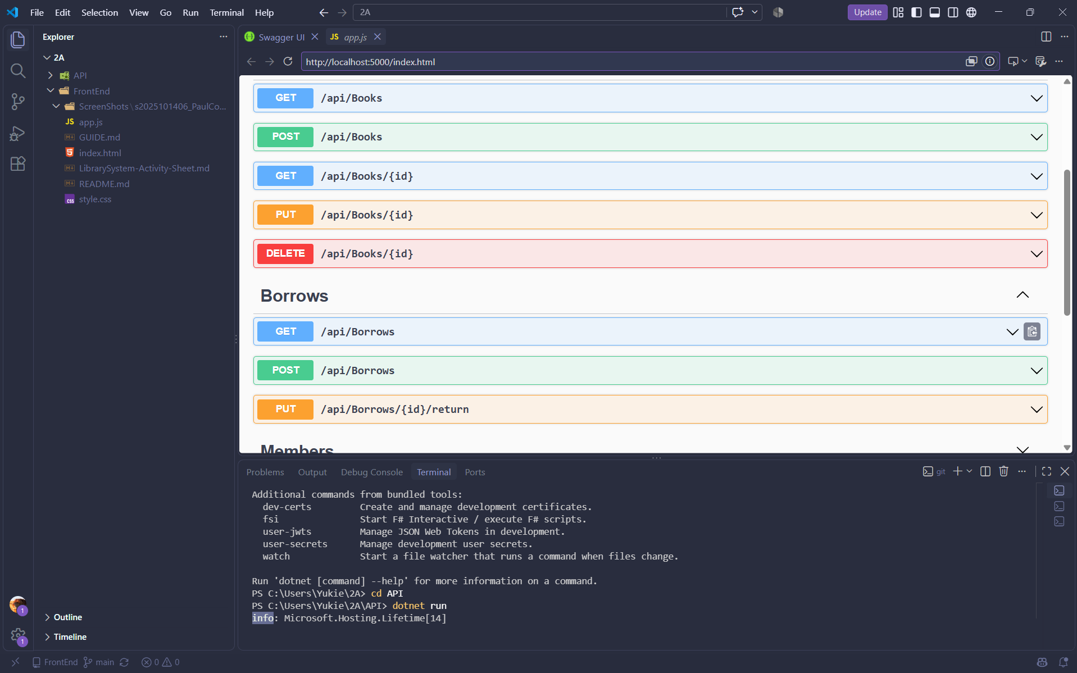

\

part - 01 - settings - apifetch

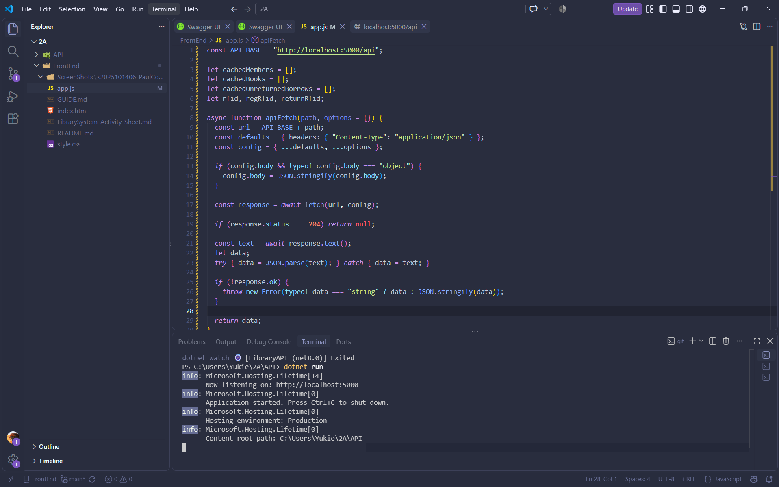

Part - 02 - showToast

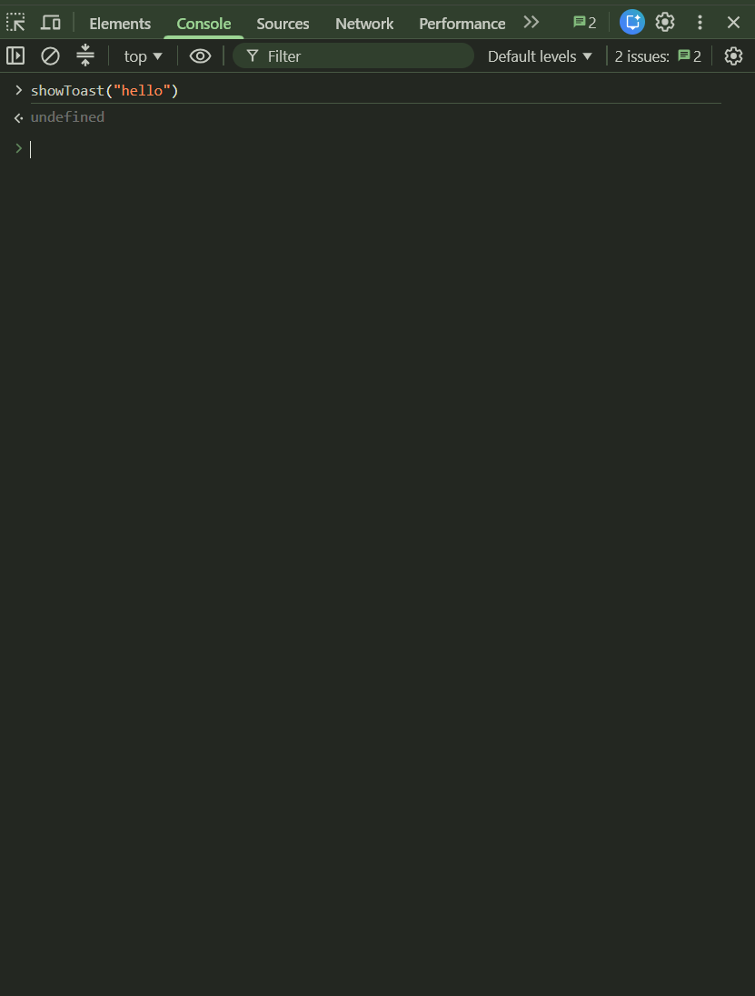
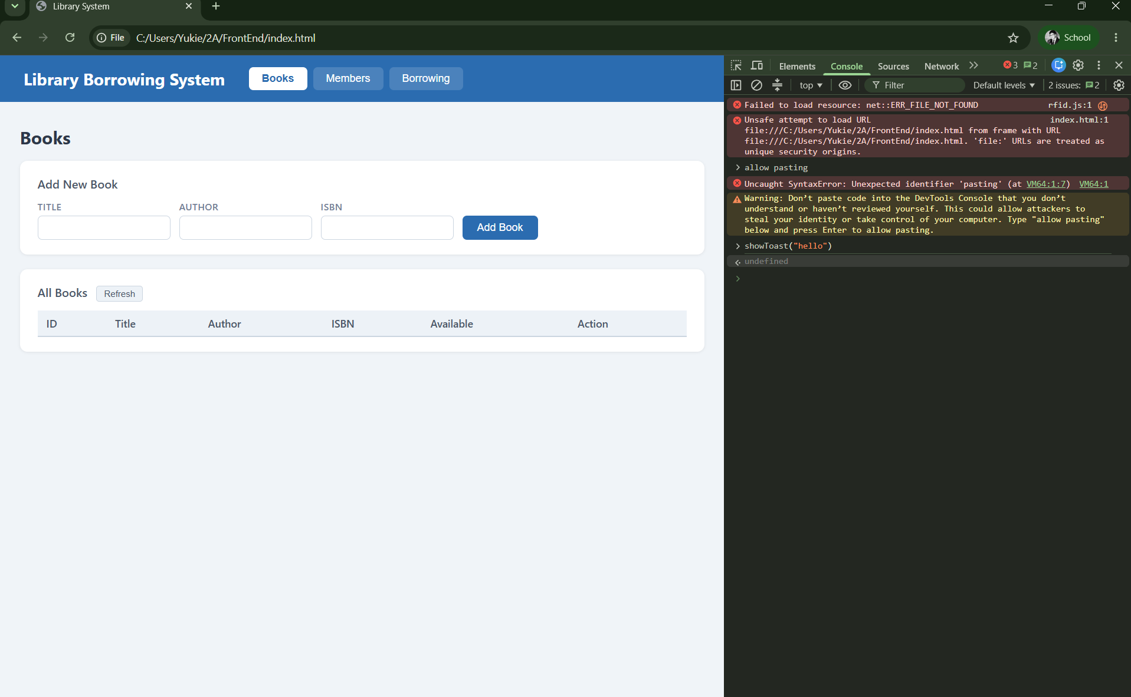

Part - 03 - cache

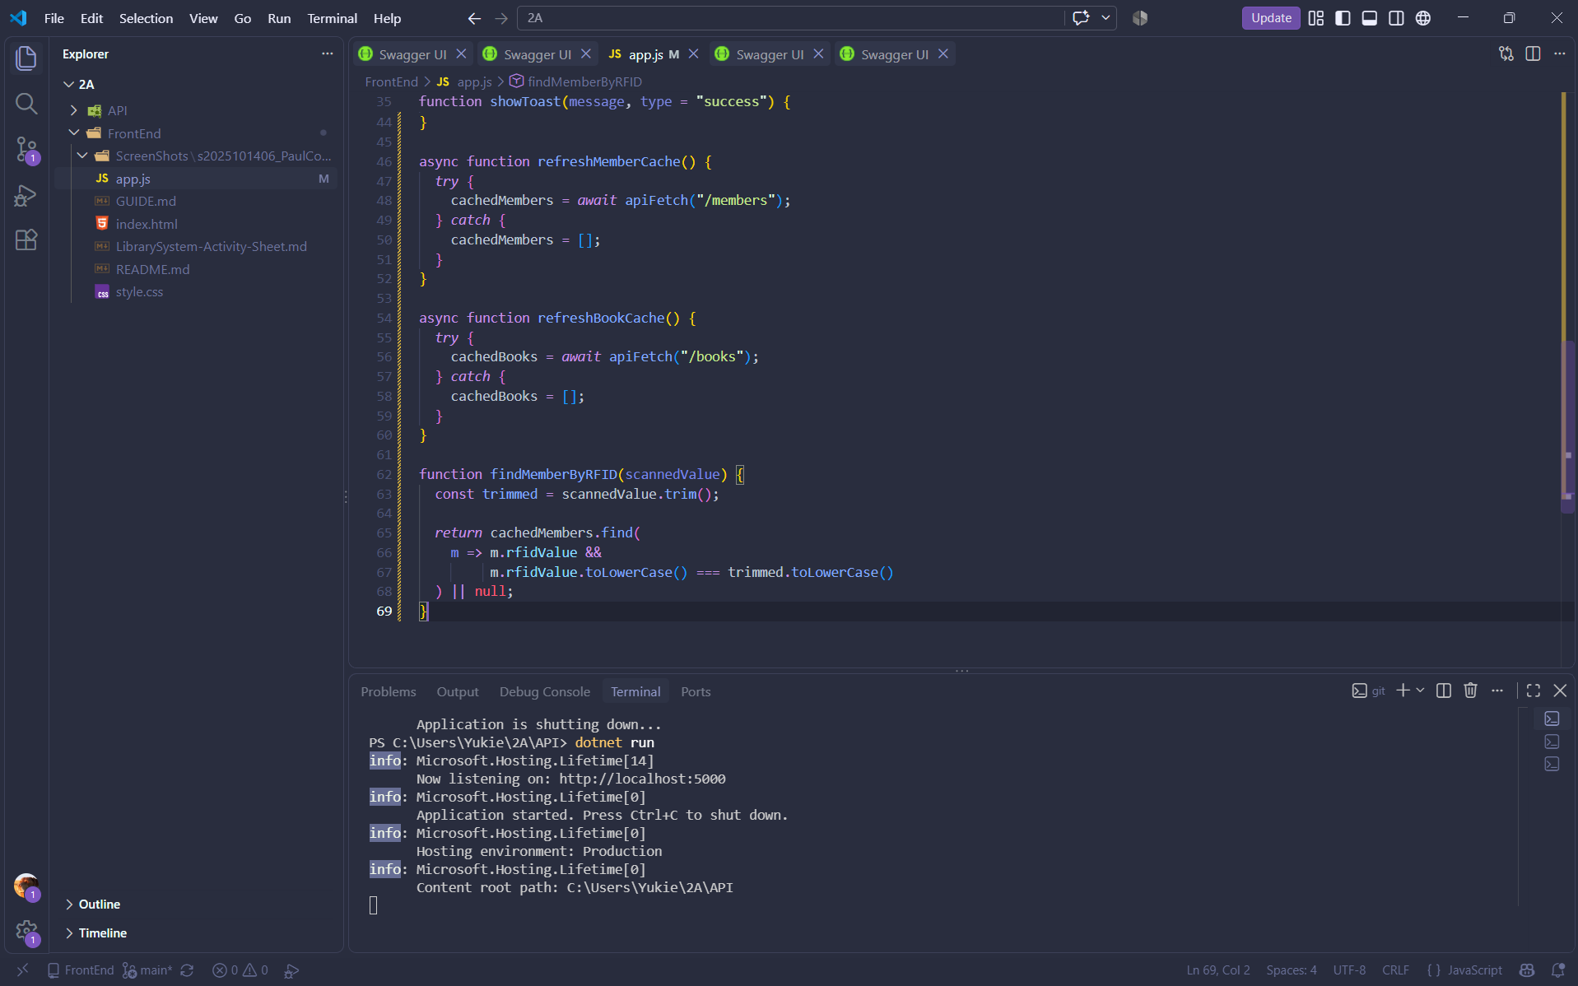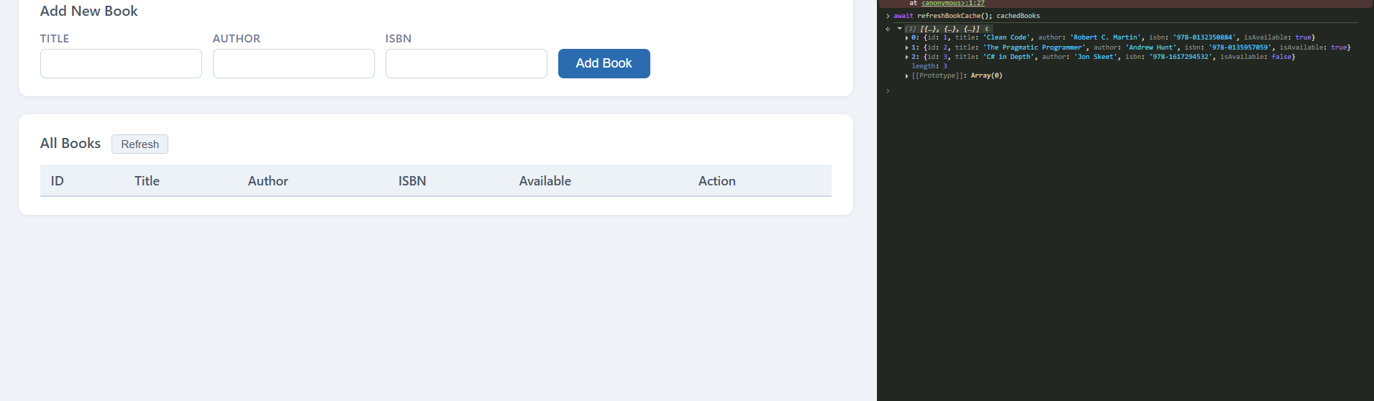

Part - 04 - tabs - reFresh
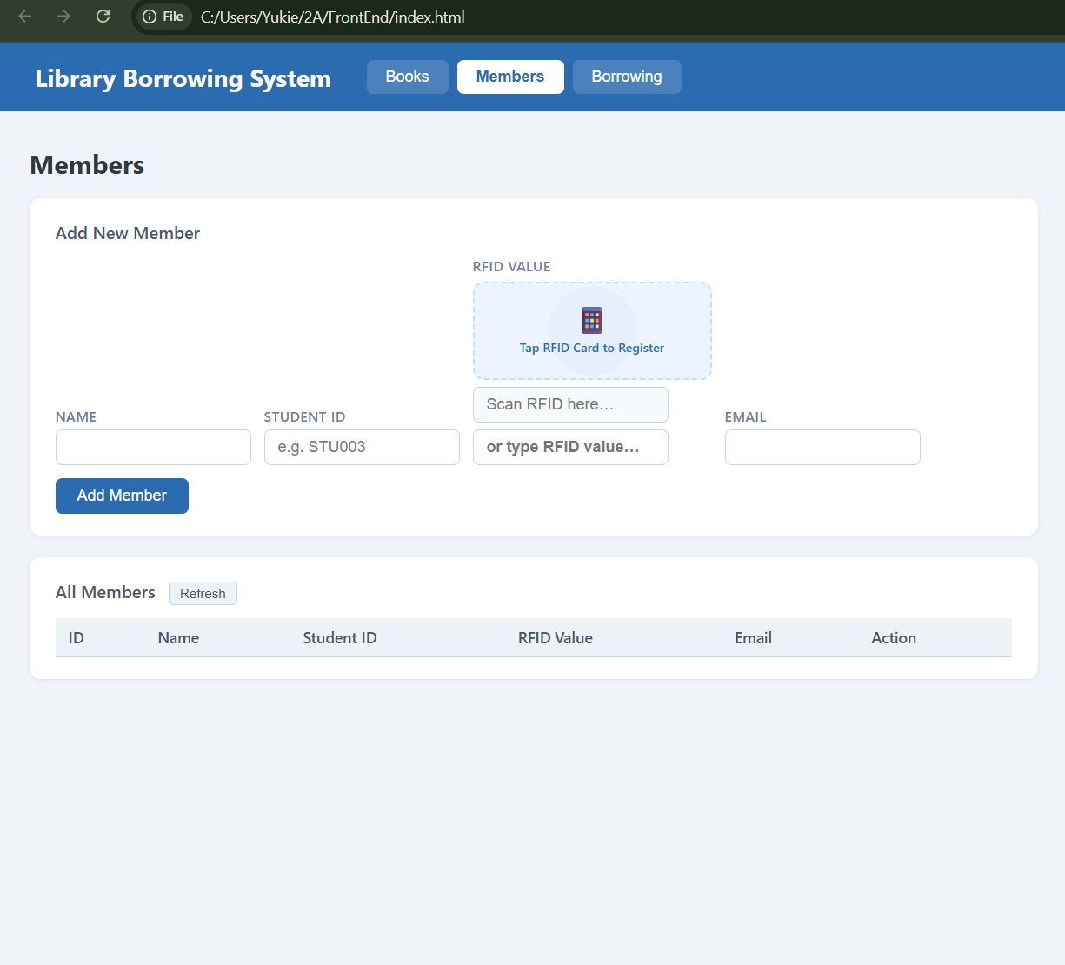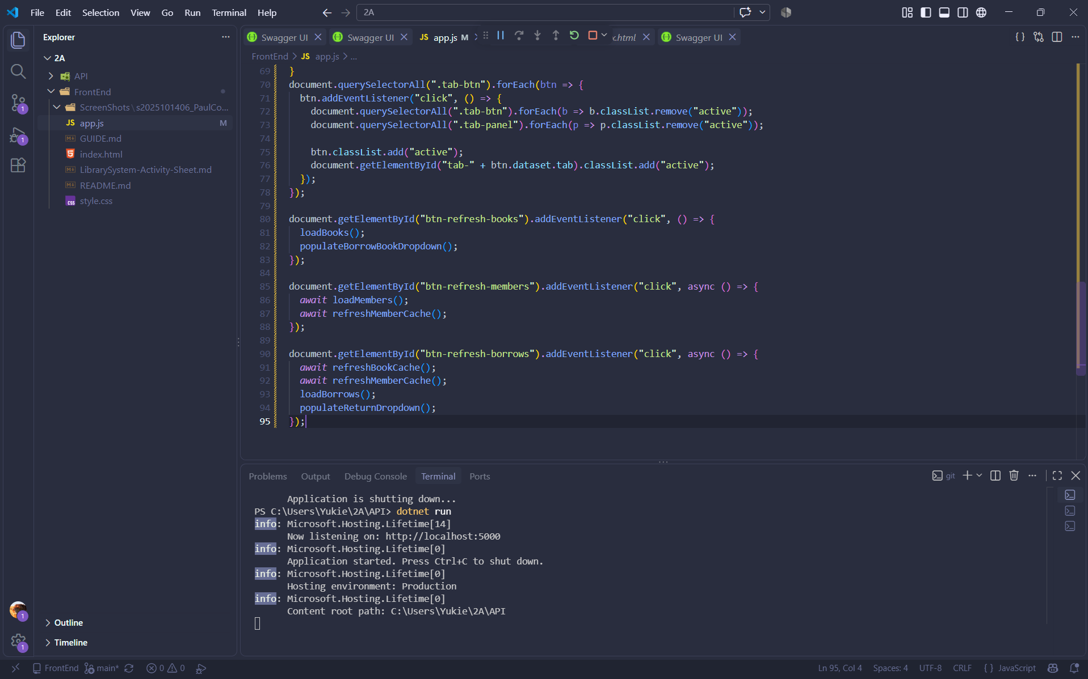

Part - 05 - loadbooks

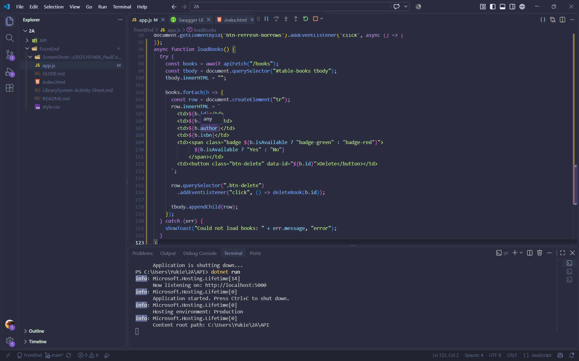

Part - 06 - deleteBooks
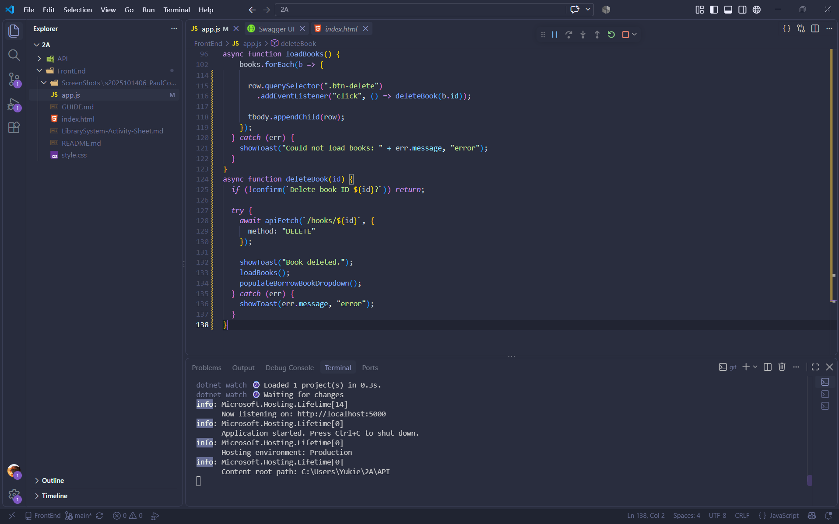

Part - 07 - addbook

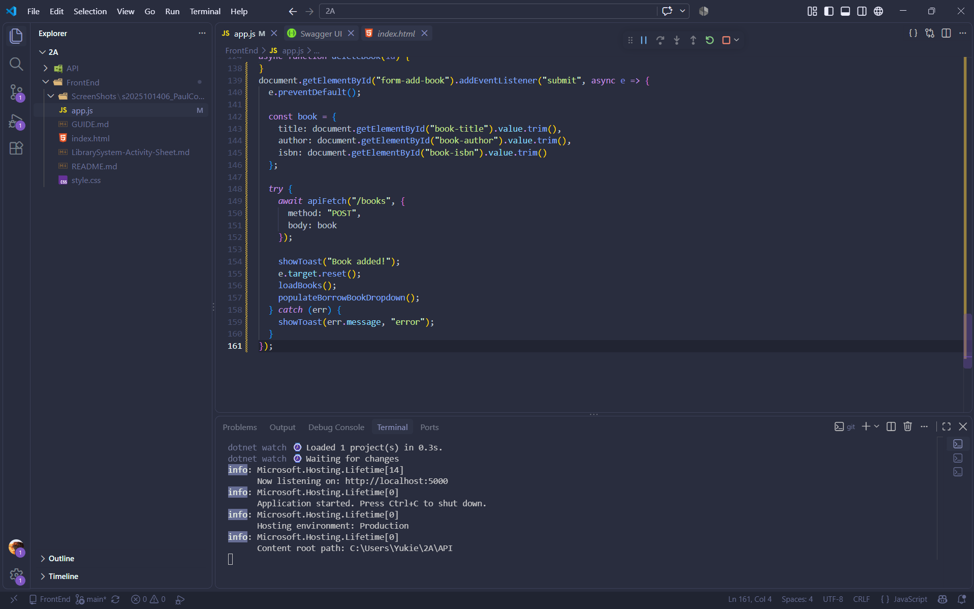

Part - 08 - load members
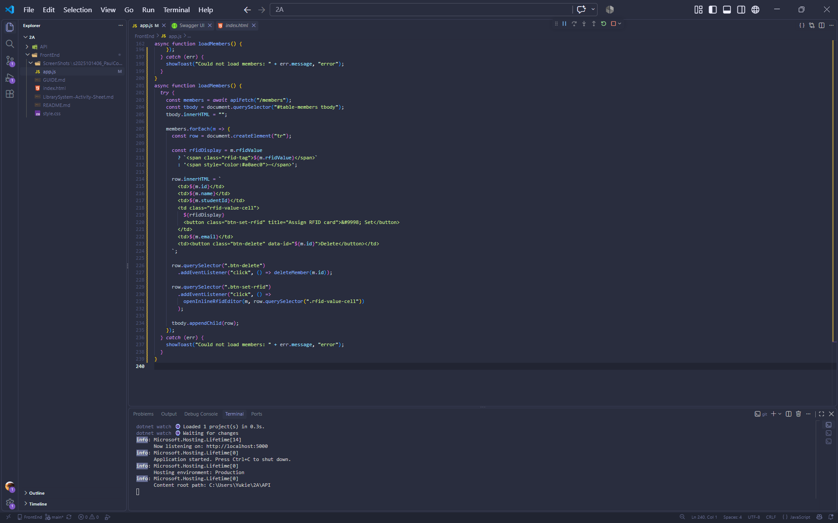

Part - 09 - deleteMember
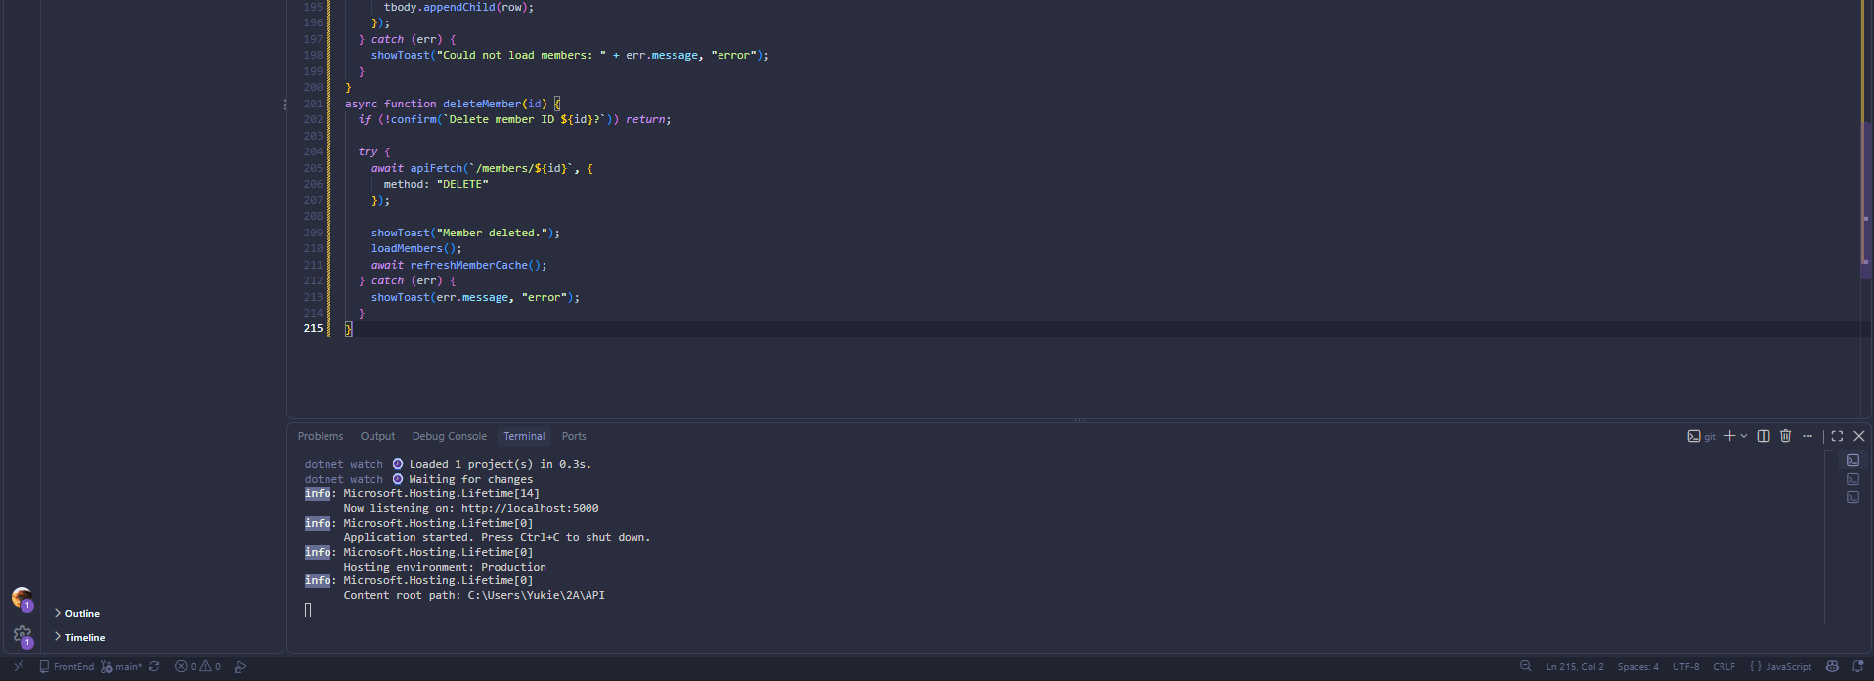

Part - 10 - Add member with RFID Value

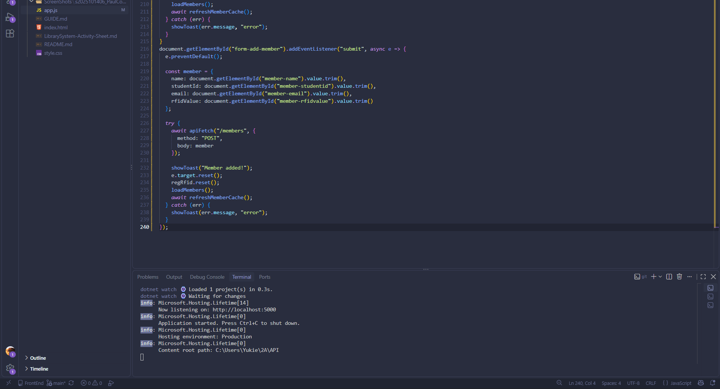

Part - 11 - inline RFID Editor and Update Member RFID
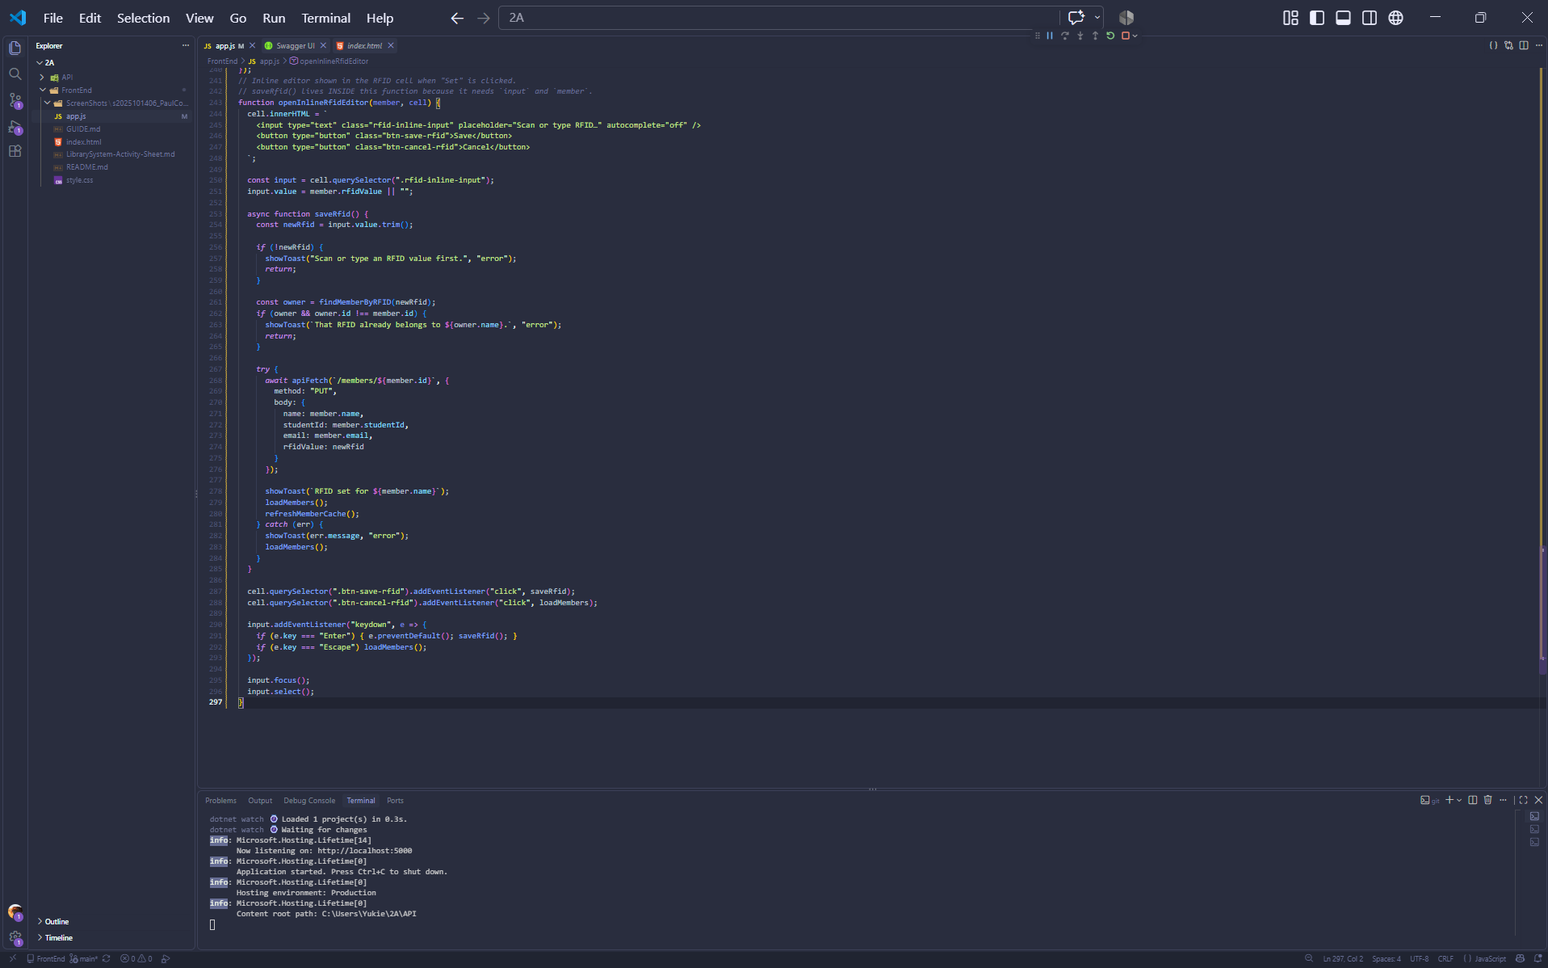

Part-12a-rfid-widget-builder

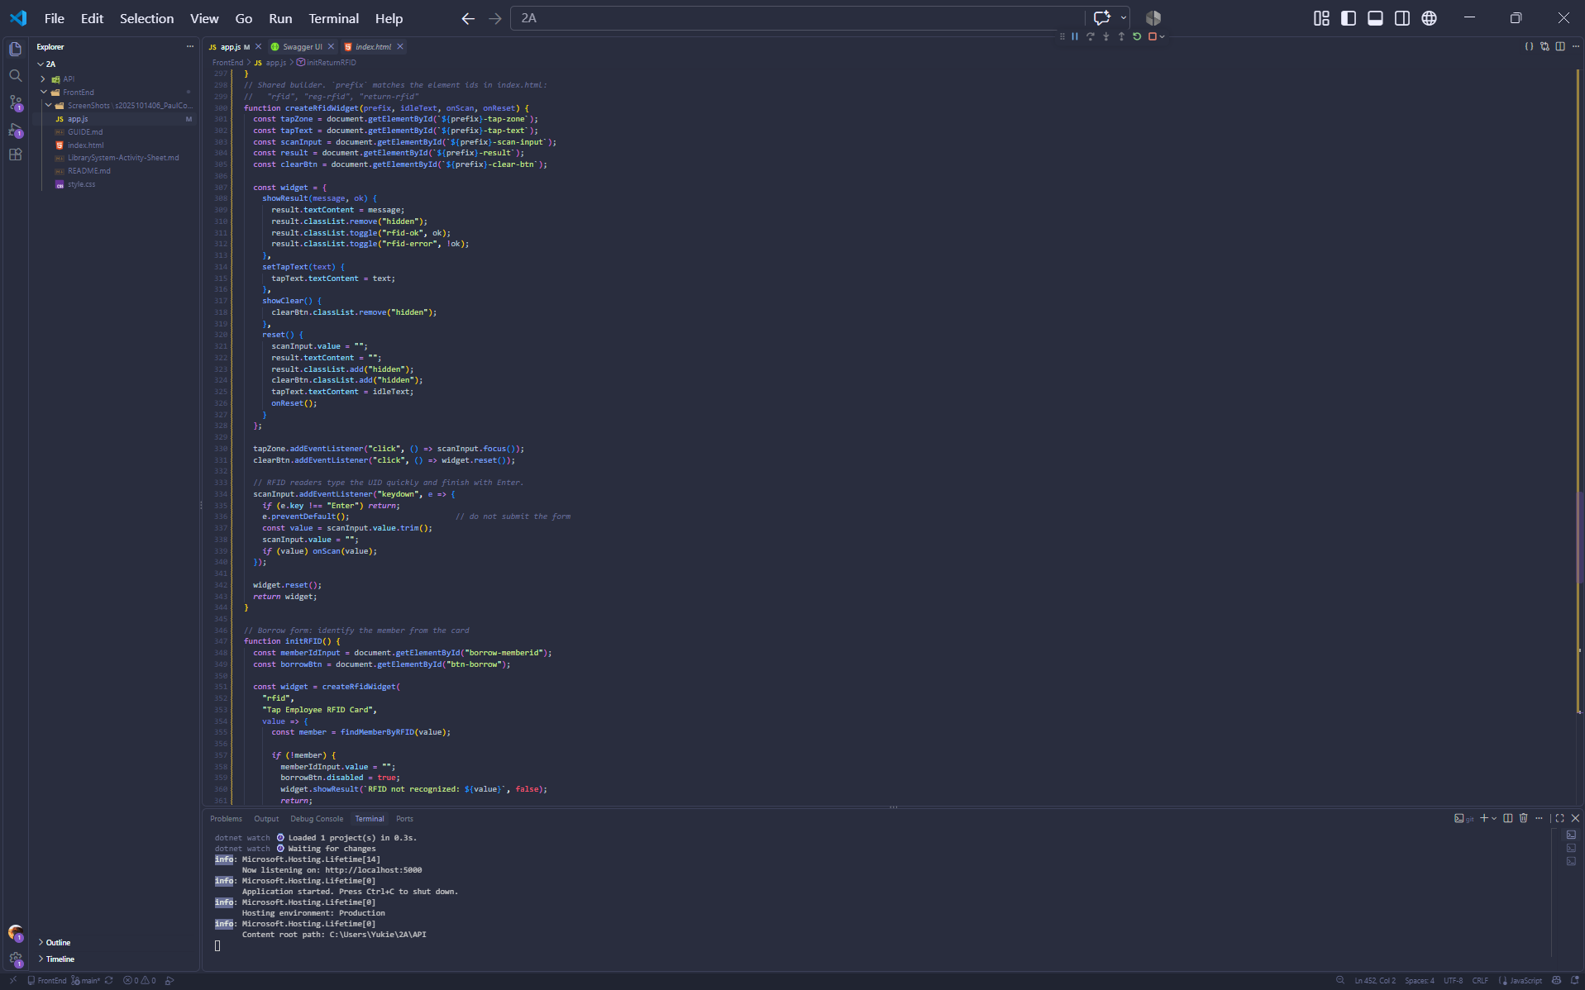

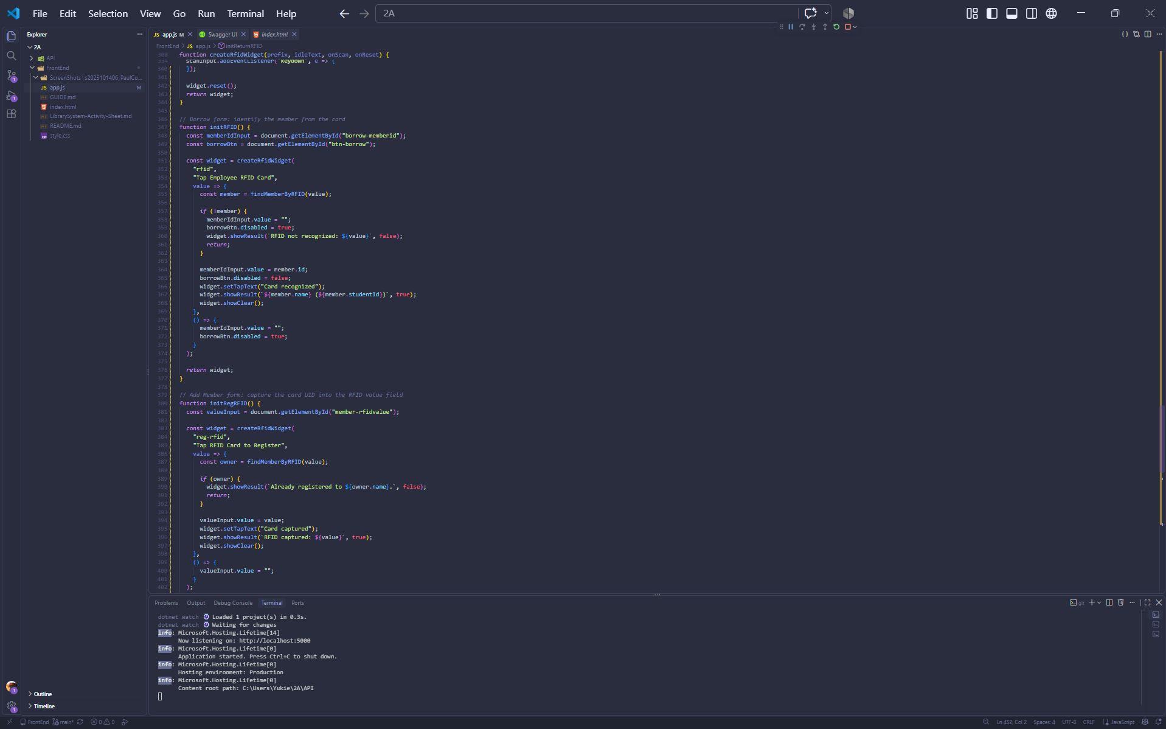
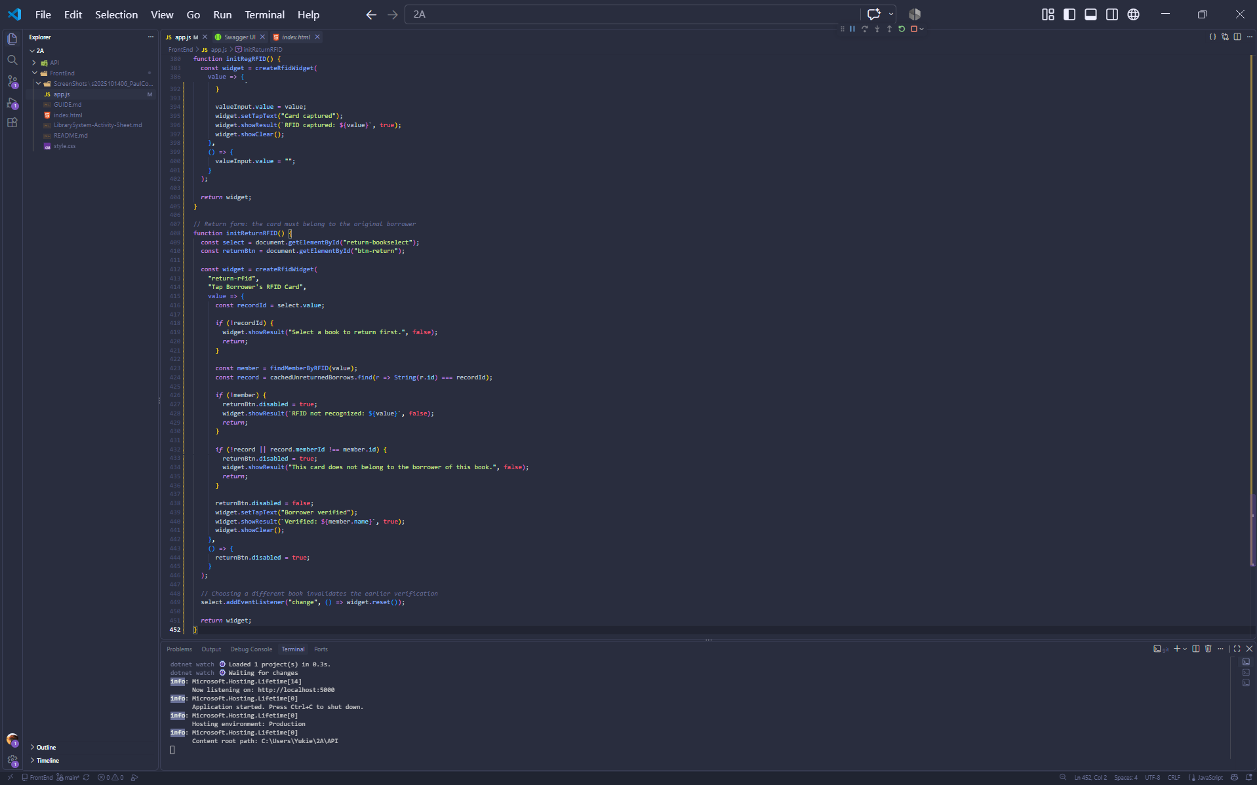

part-13-borrow-dropdown

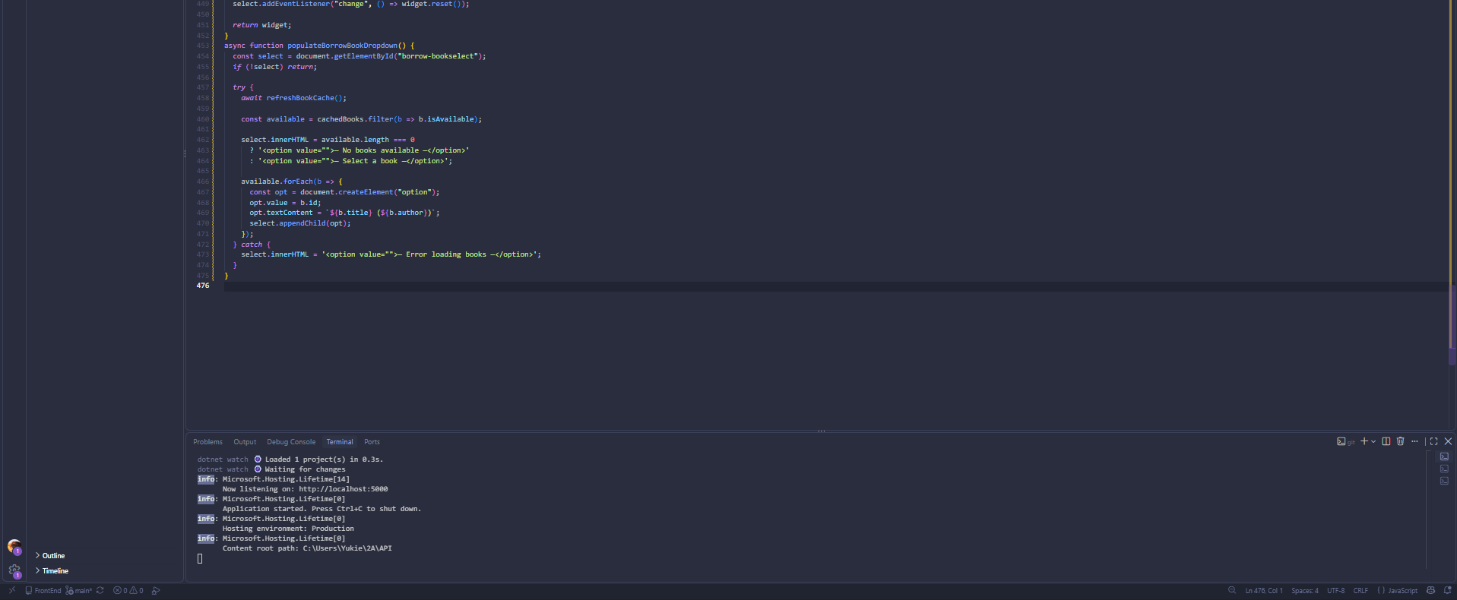

part-14-return-dropdown
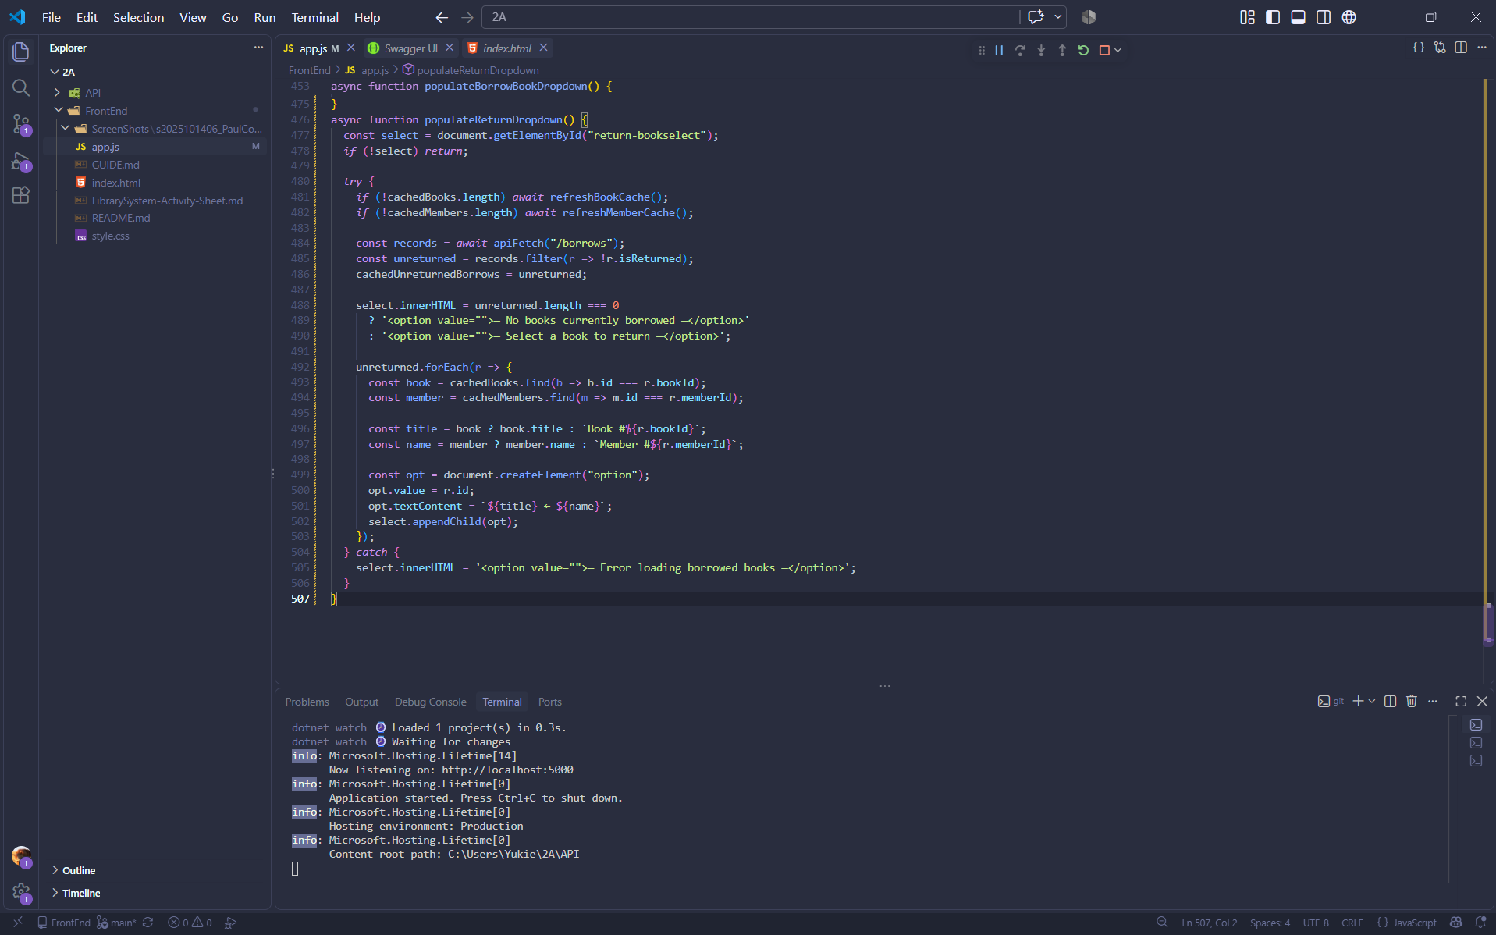

part-15-borrow
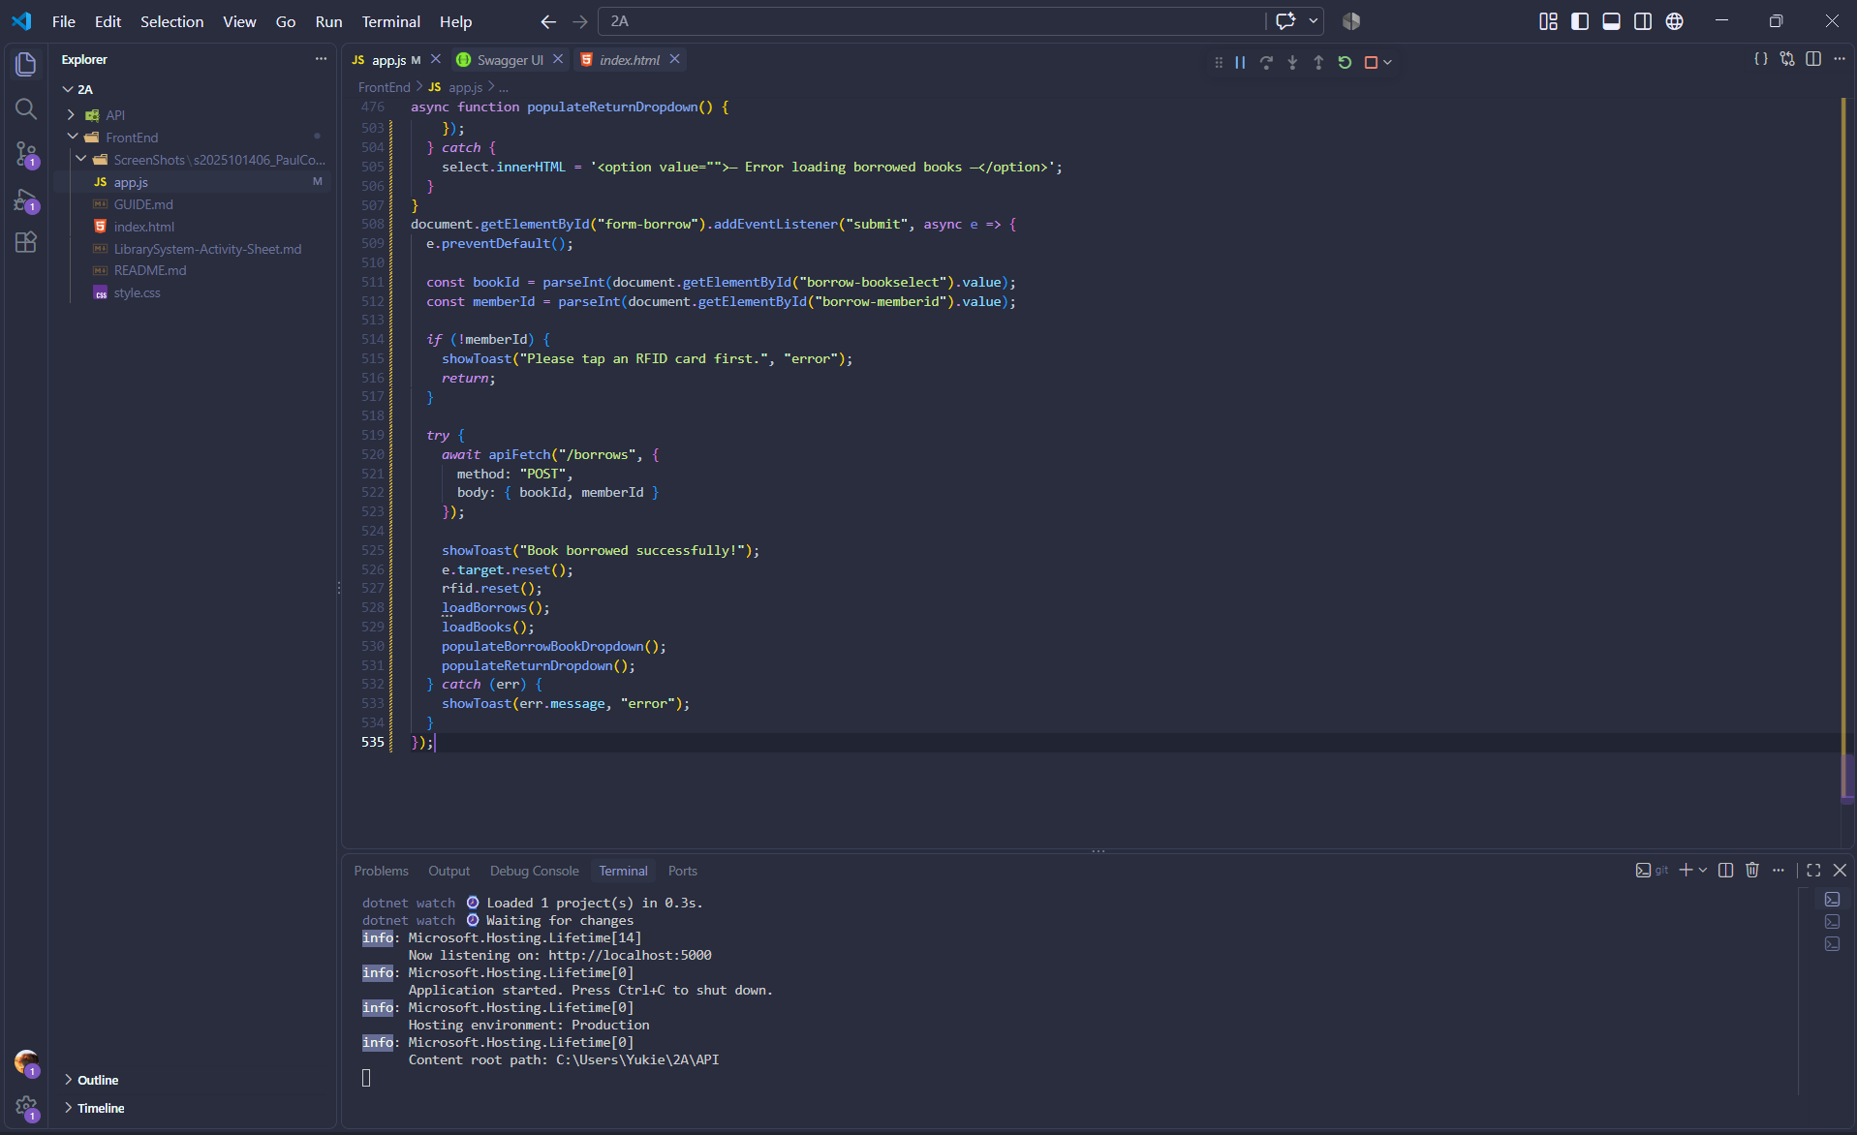

part-16-return
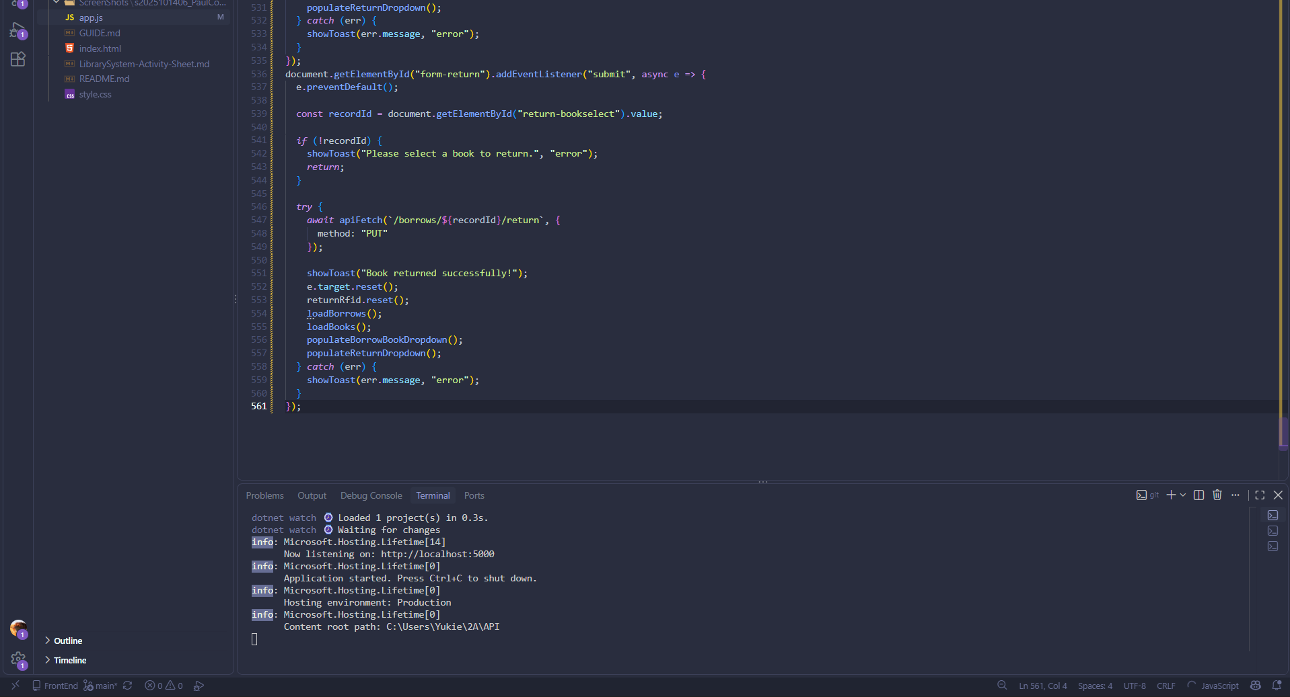

part-17-loadborrows
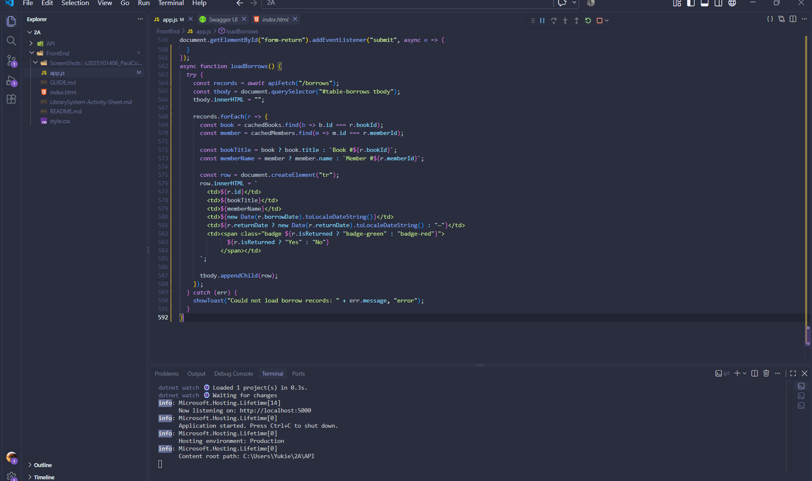

part-18-page-load
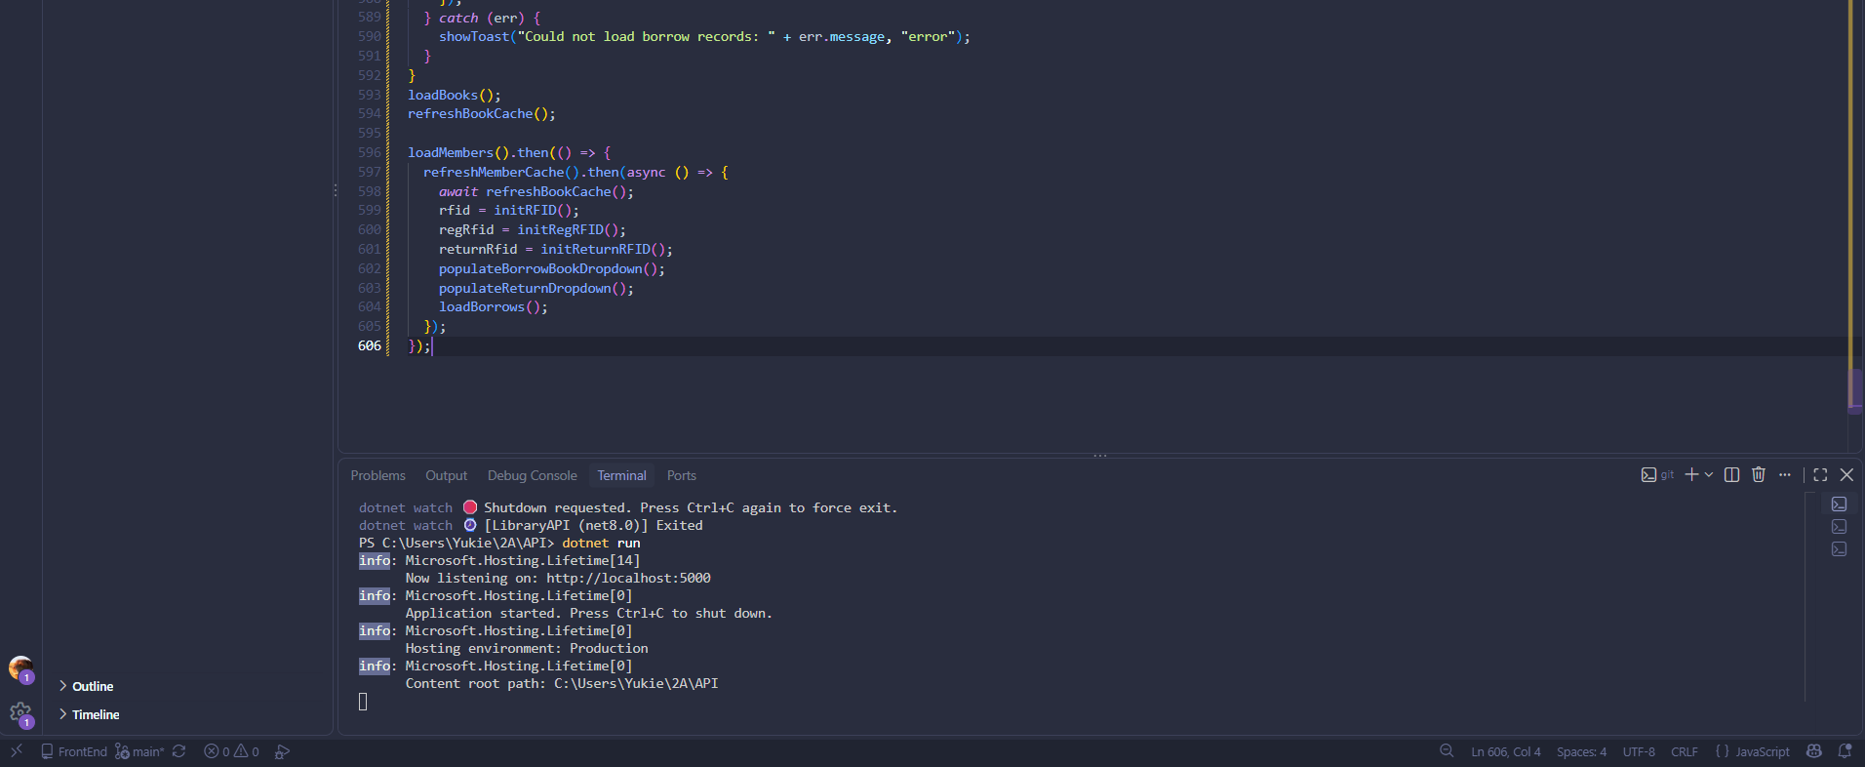

1. Start the API

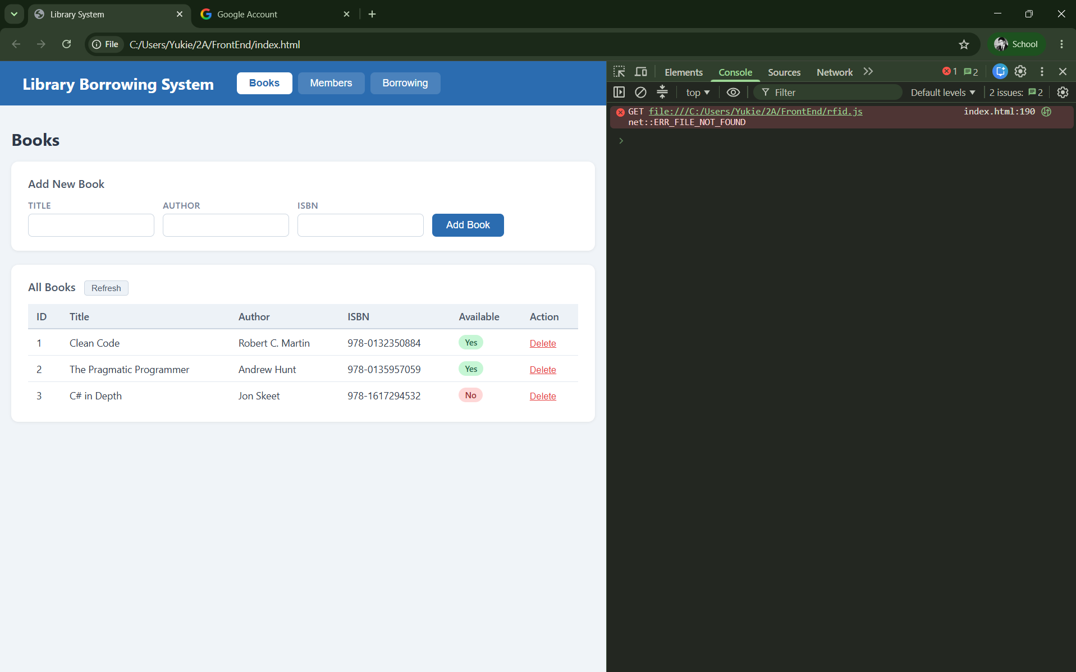

2. Open the FrontEnd

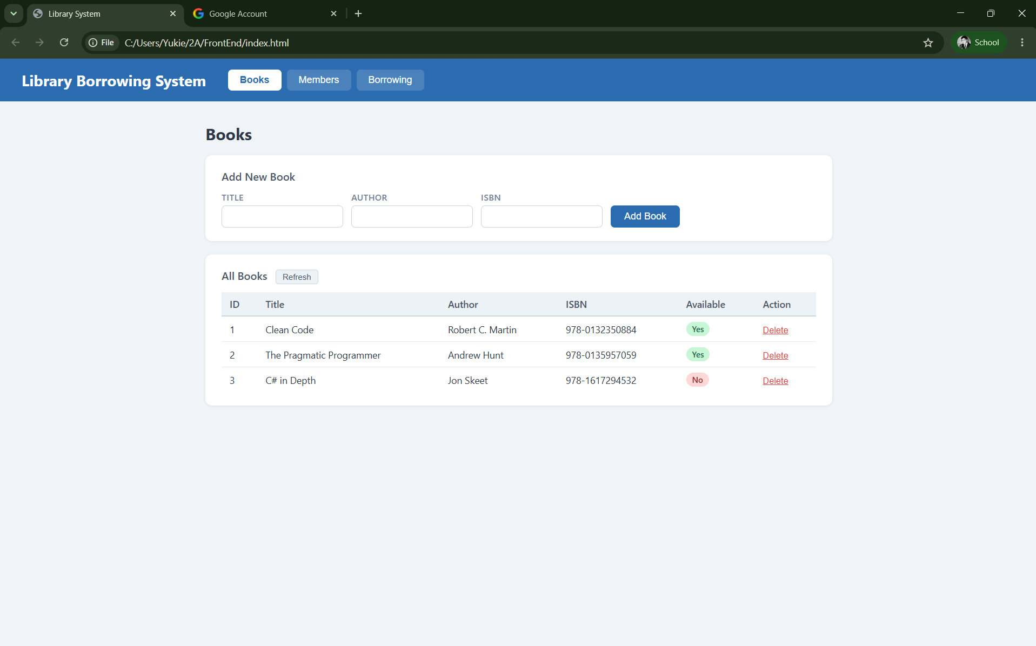

3. Test the Tabs

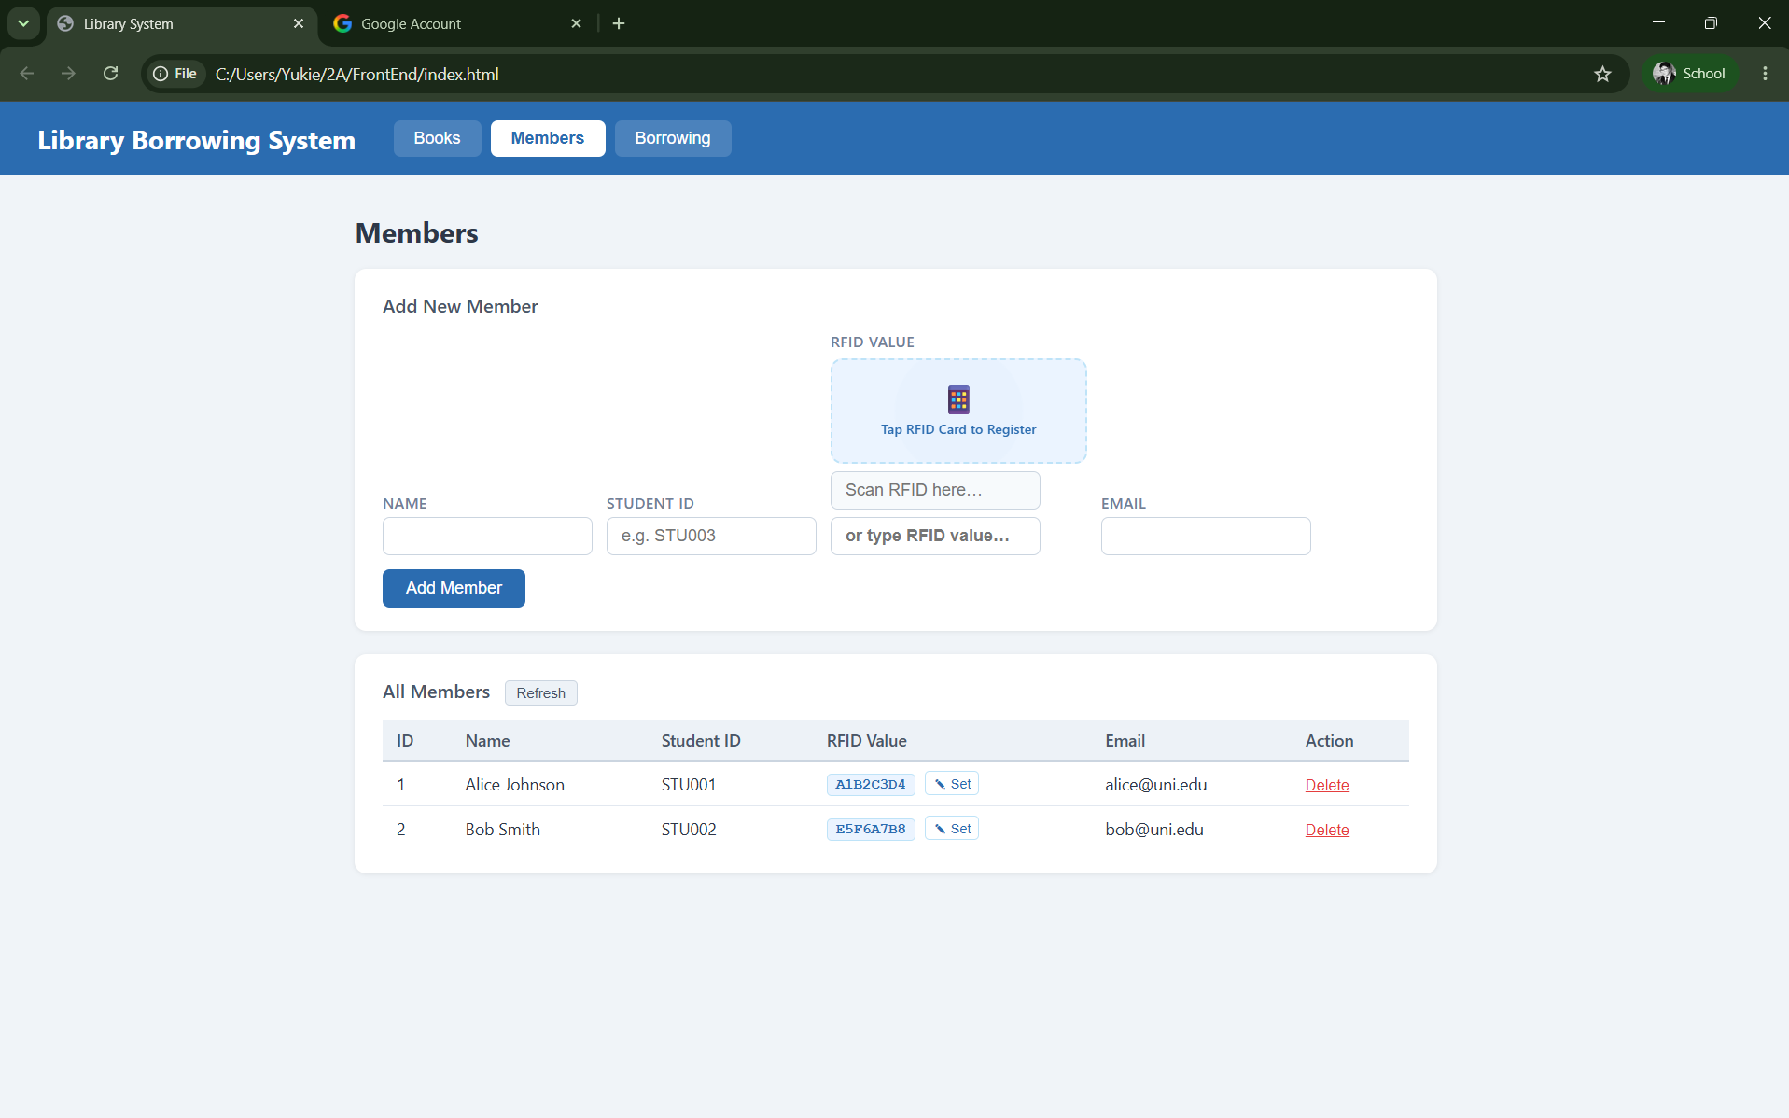
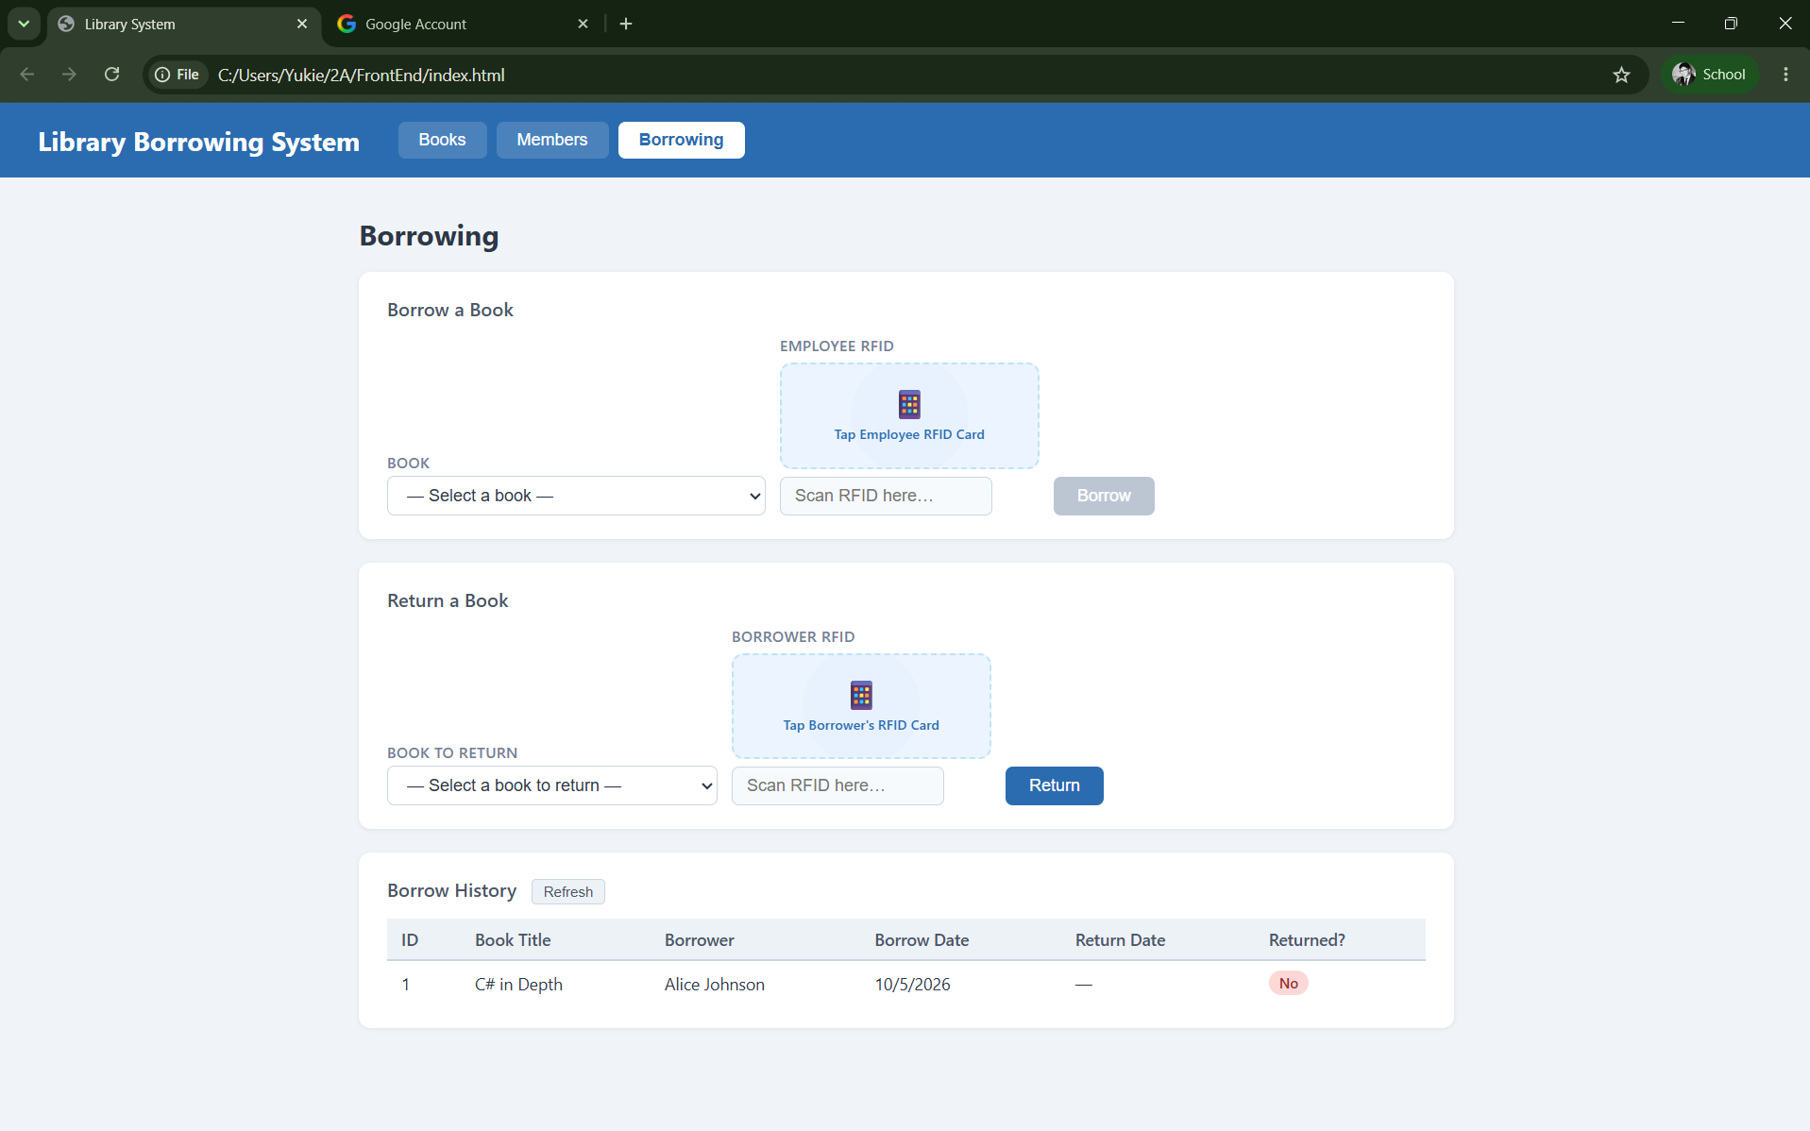

4. Test Books
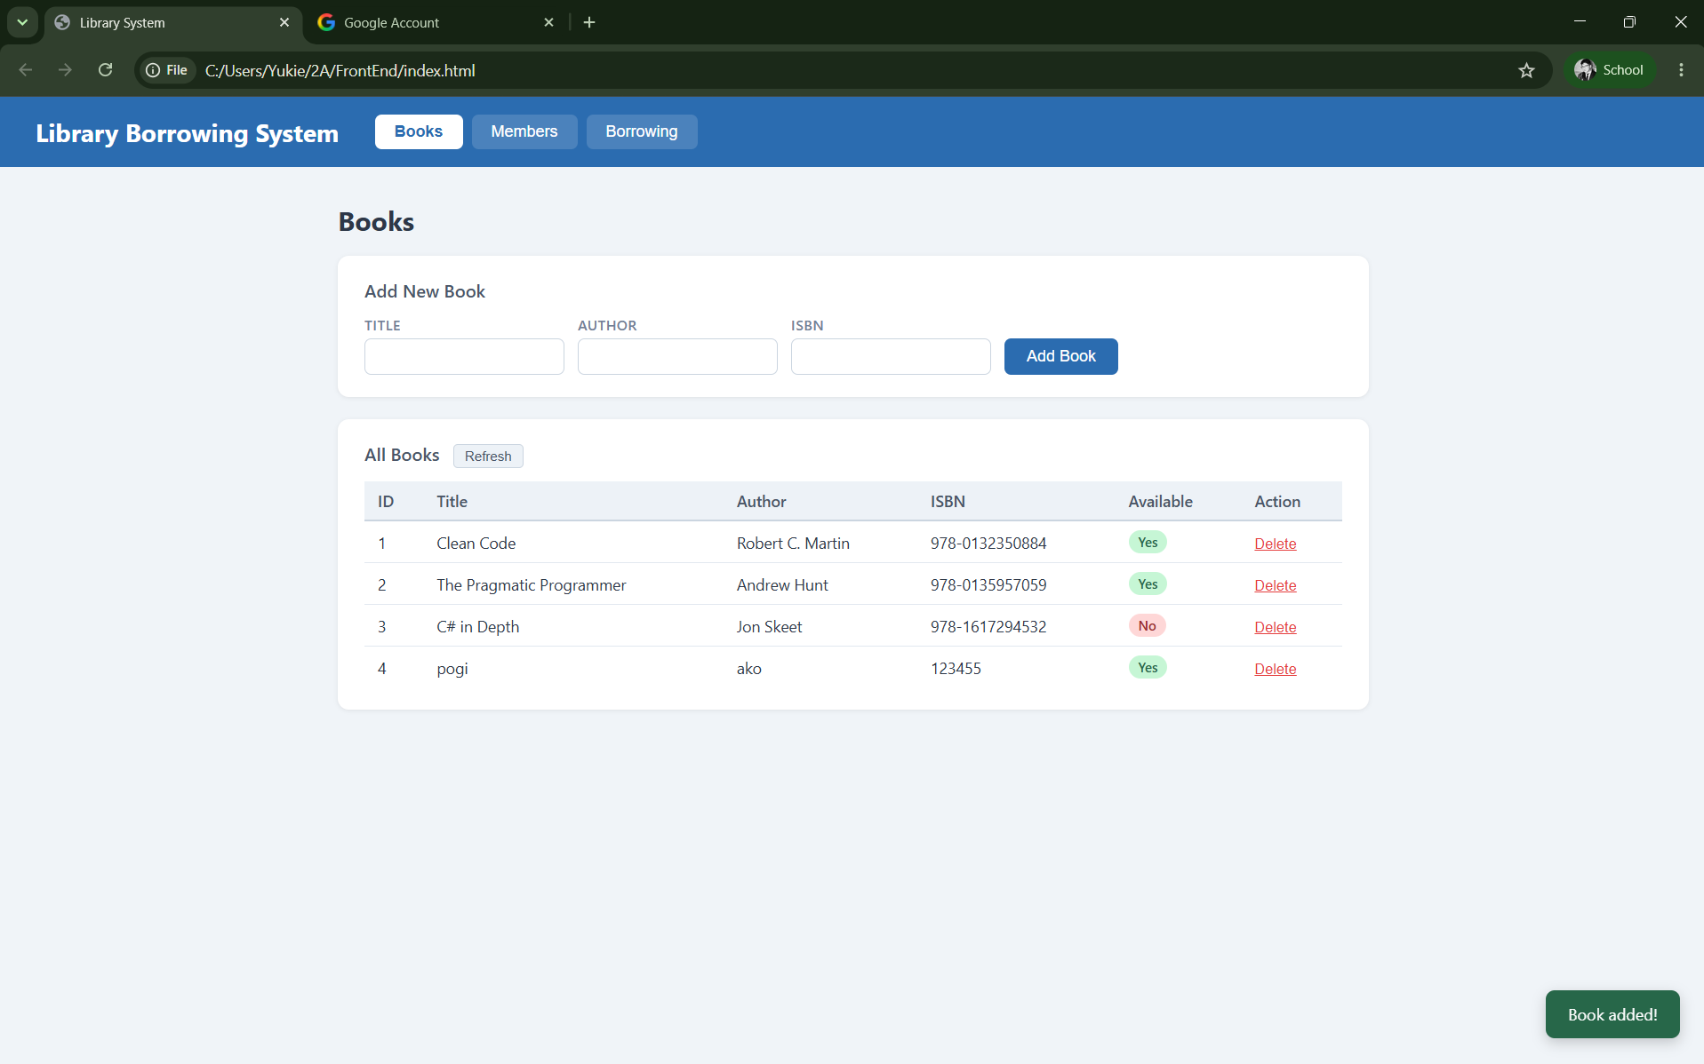
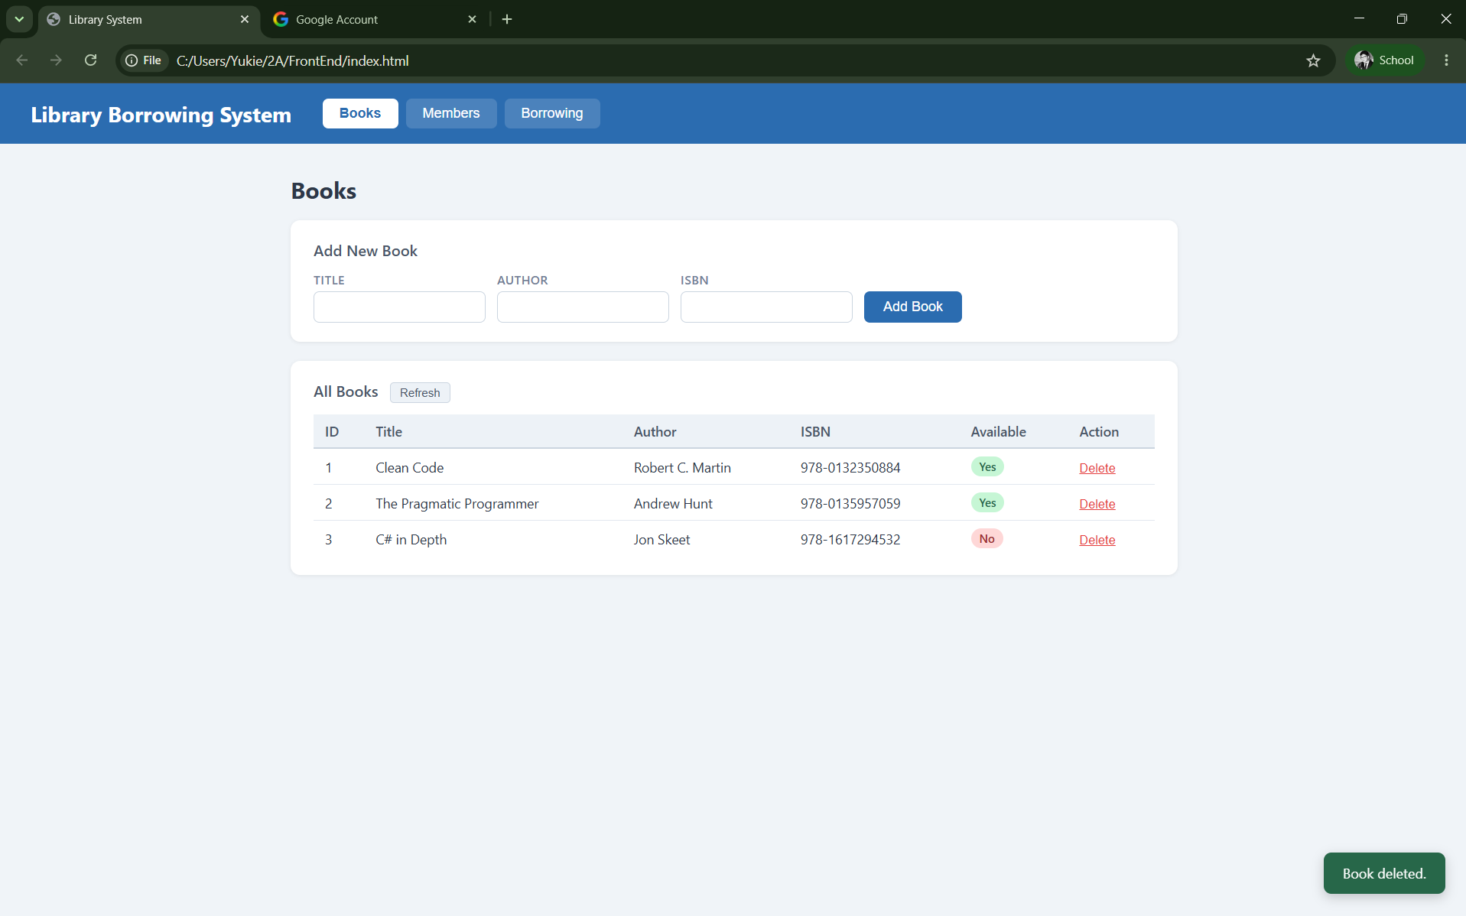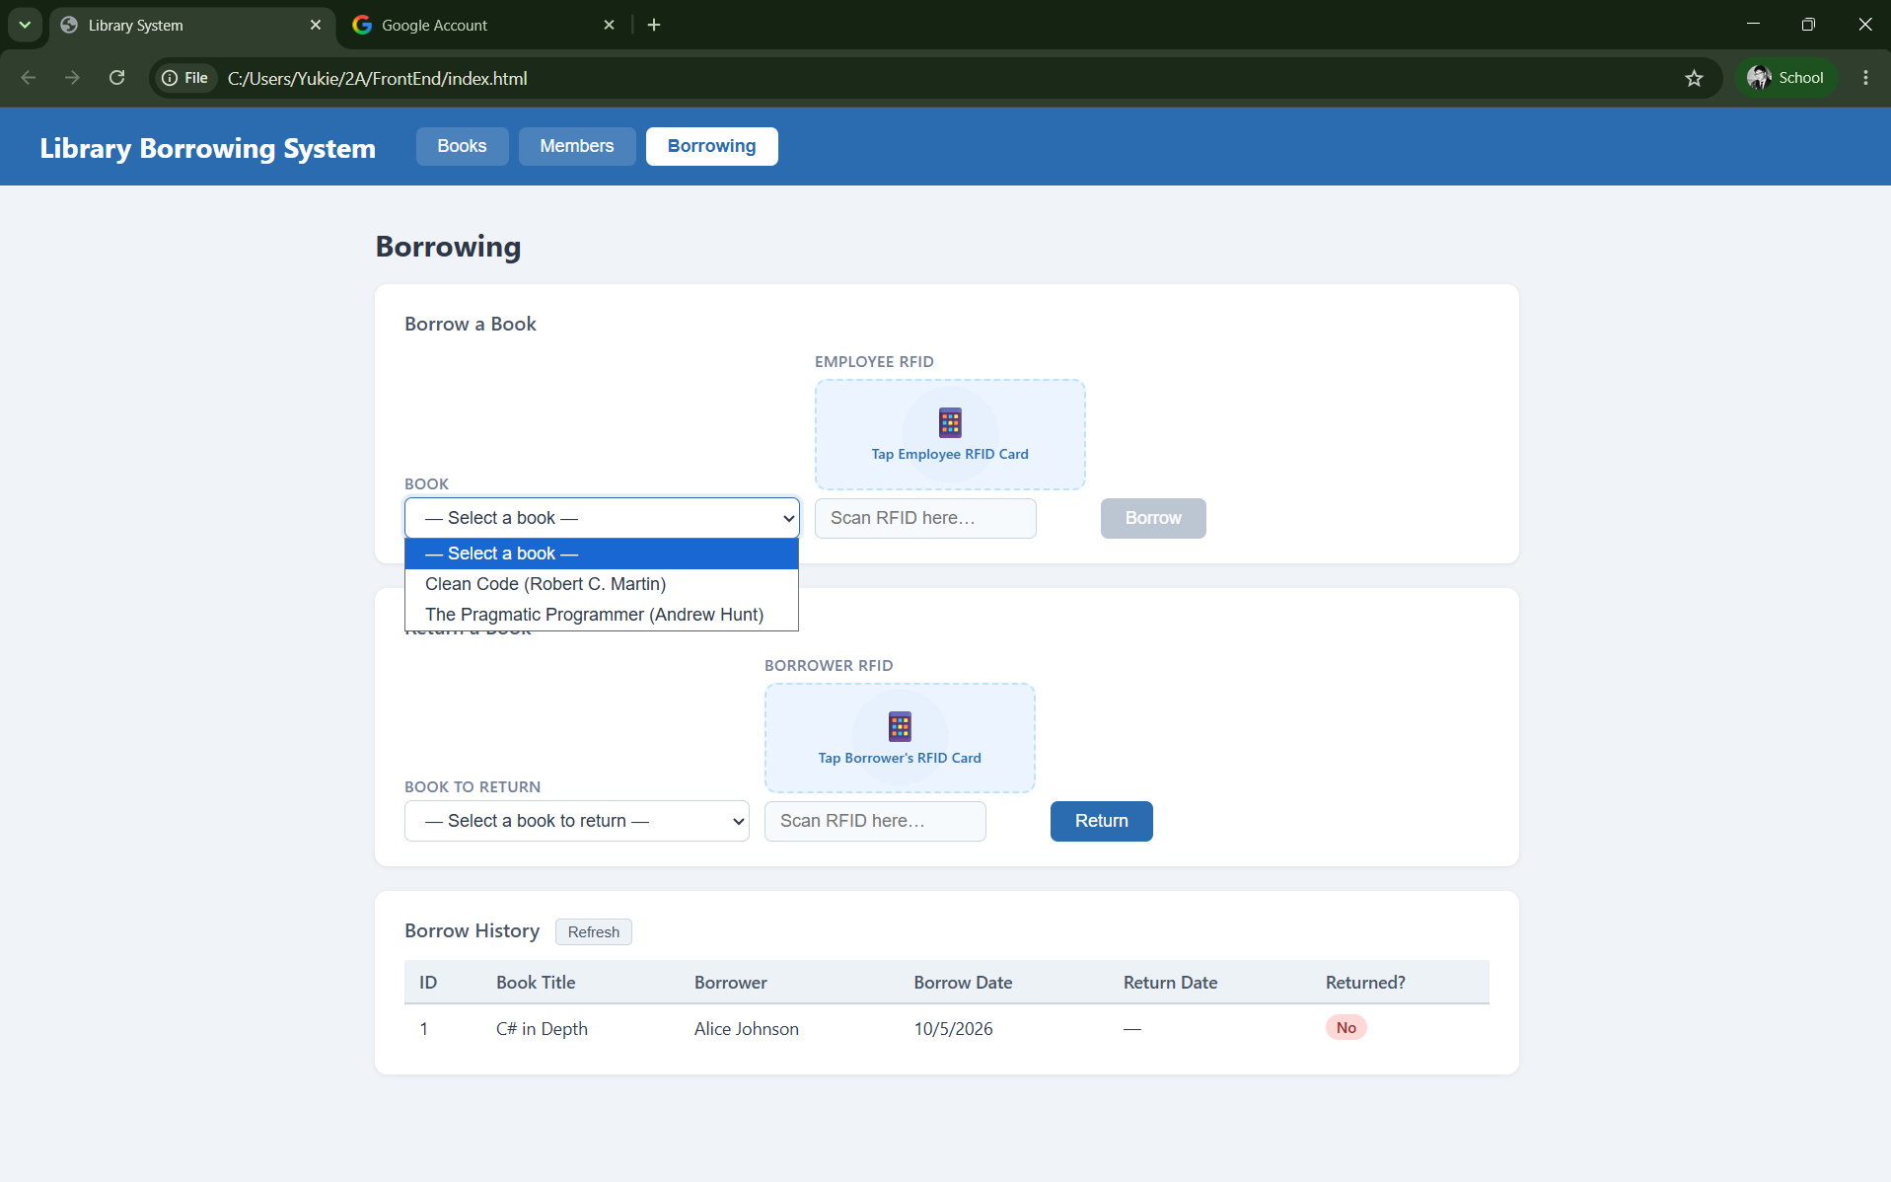\

5. Test Members
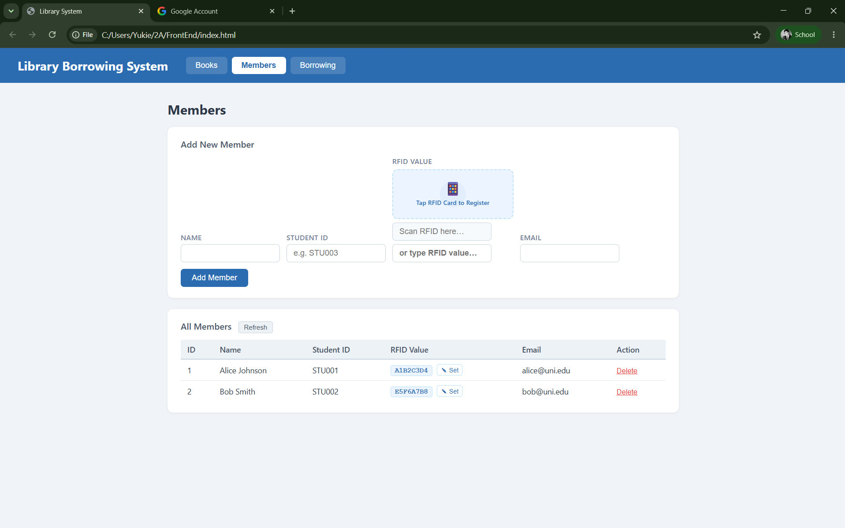
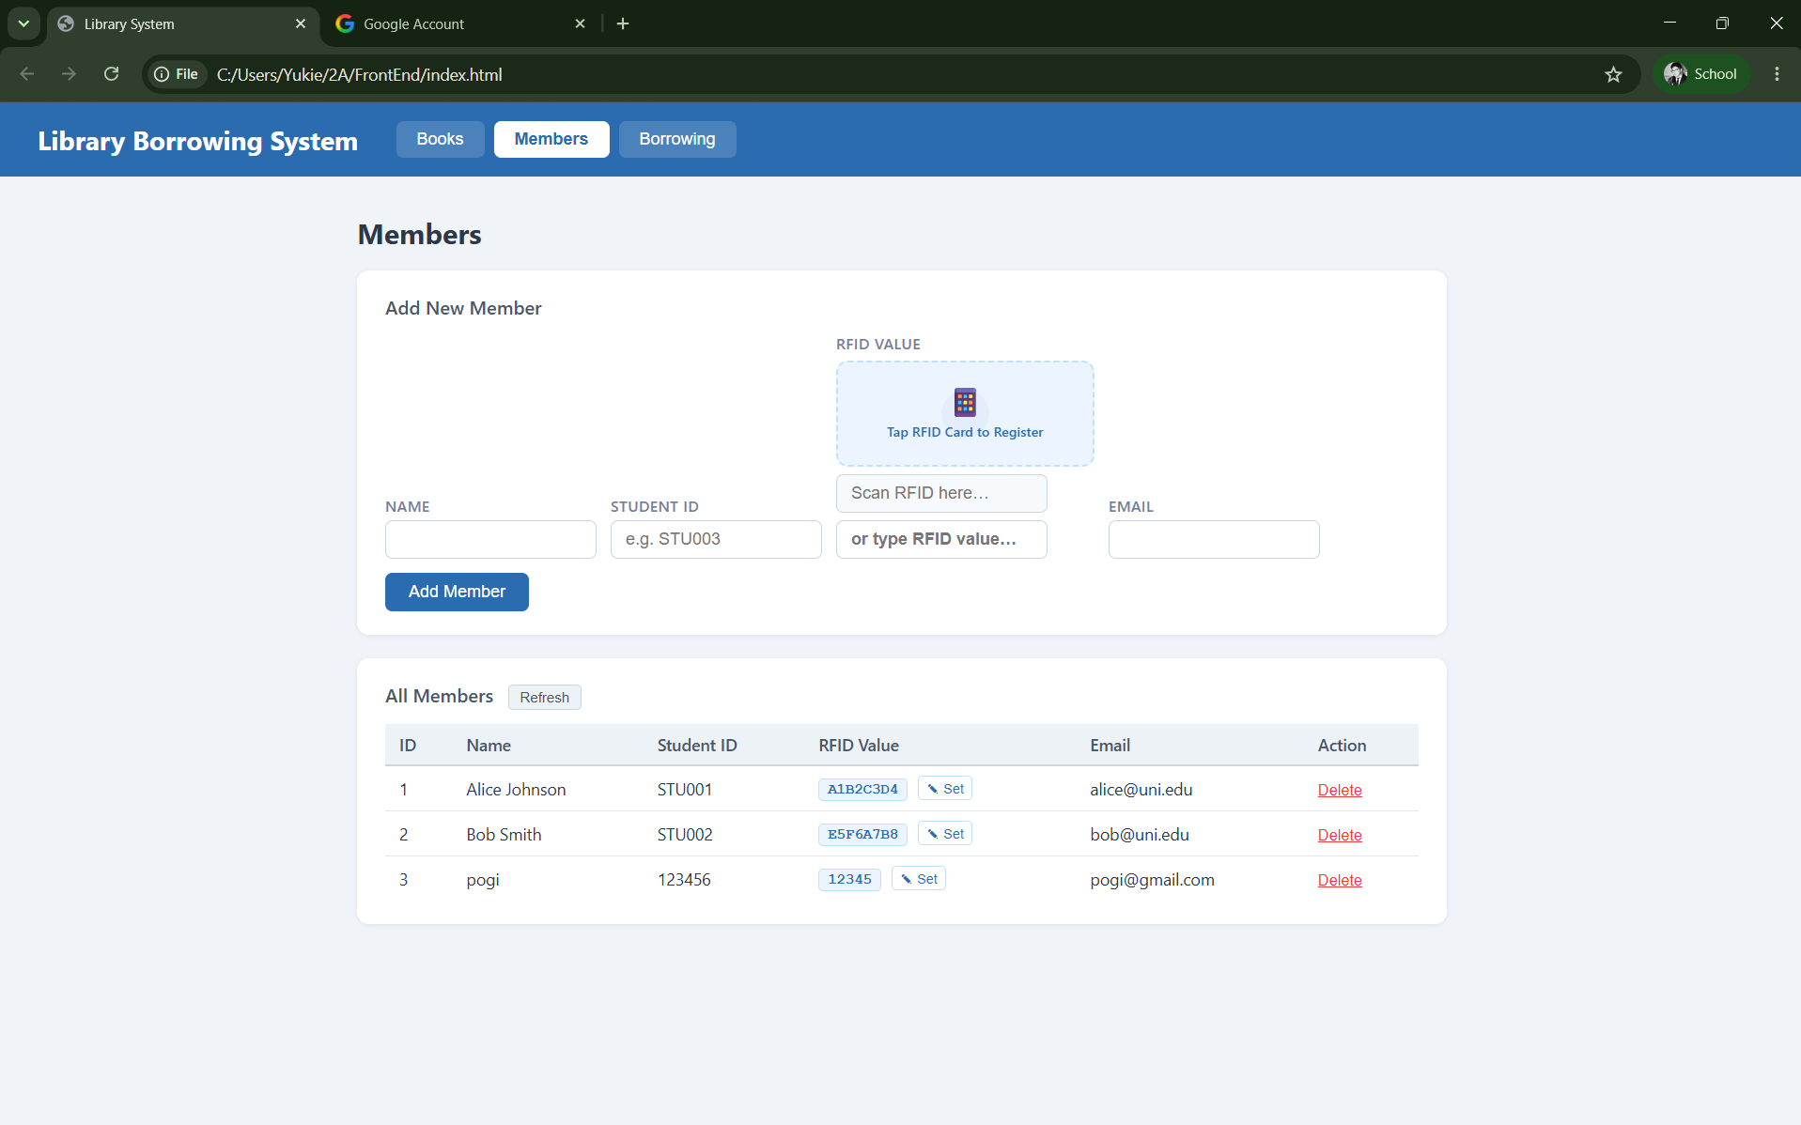

6. Test Borrowing

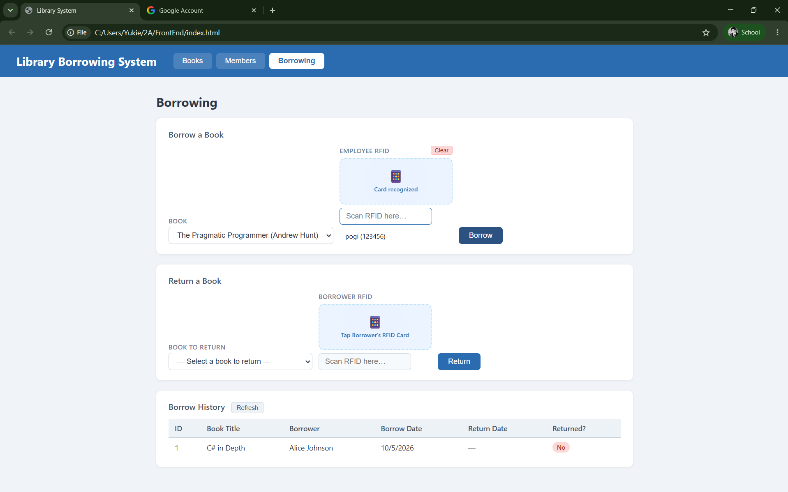
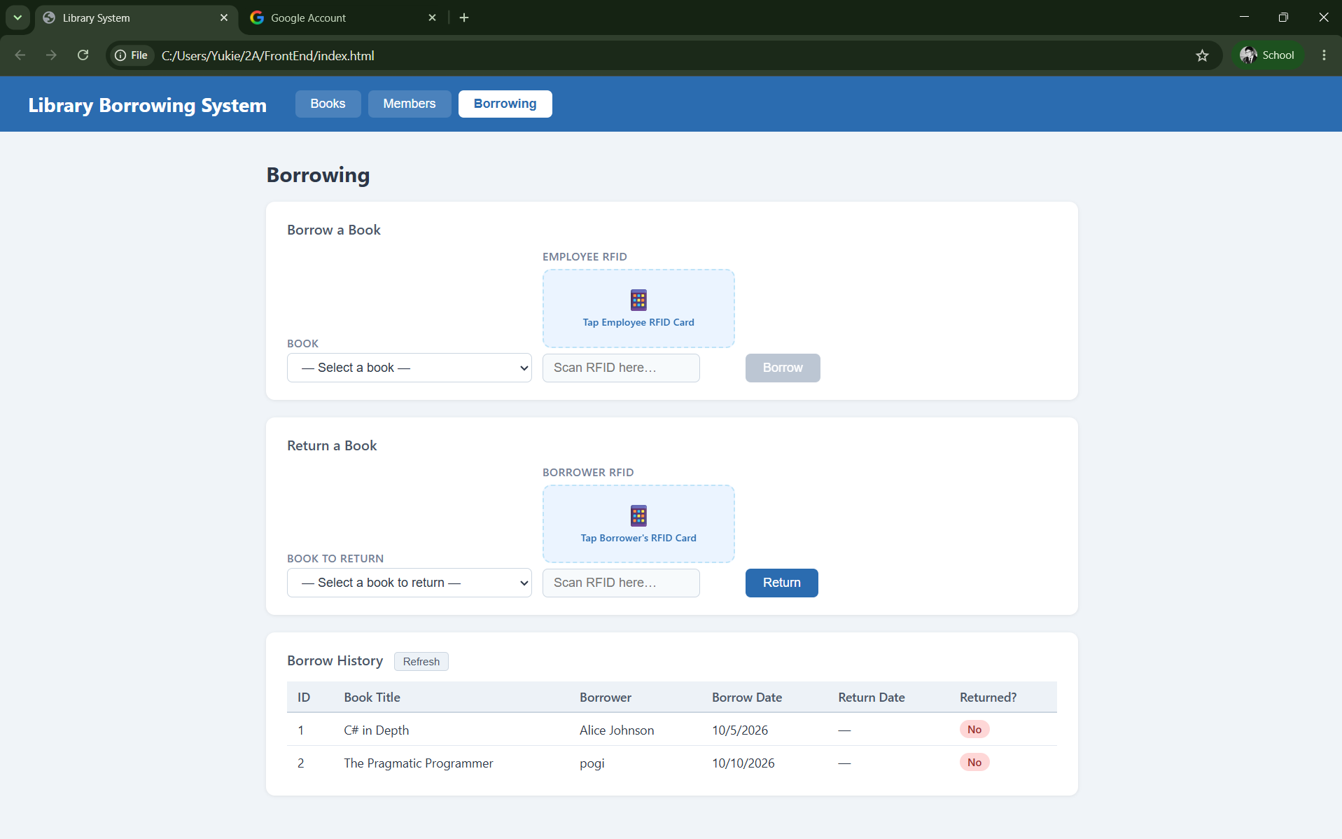

7. Test Returning

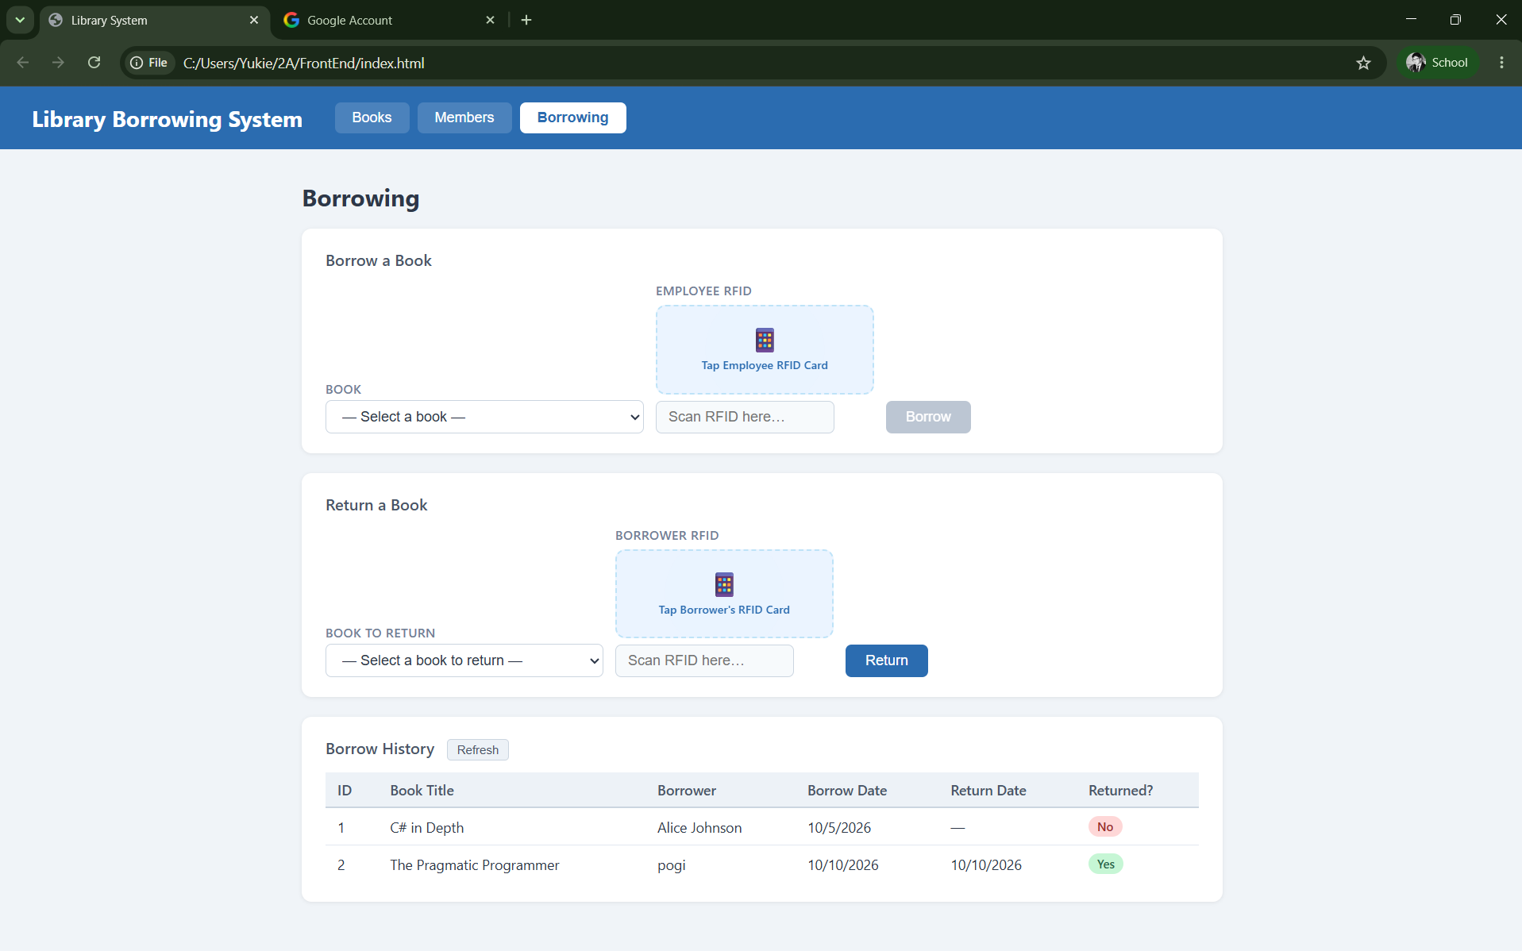

- What does apiFetch() do?
- Why do we use try/catch around API calls?
- What is the difference between POST and PUT?
- Why does RFID matching use rfidValue instead of studentId?
- Why do we refresh tables after adding, deleting, borrowing, or returning?
- Why does the Return dropdown use borrow record ID instead of book ID?
- What happens if the same event listener is added to a form twice?
- Why must the page-load code be at the bottom of the file?
- Why does an RFID reader need e.preventDefault() on the Enter key?

- Browser function for calling an APi
- Used to handle errors
- Creates a new resource on the server / updates an existing resource
- Uniquely identifies the physical card being scannced rather than manually
- To ensure the UI reflect the most up to date database state
- Because the transaction itself if tracked by the unique borrow record
- The event listening will fire multiple times
- To ensure that all HTML DOm element have finished loading and existing
- To prevent the forms default page reload behavior when the user presses enter after scanning an RFID

